**Module 1**

Distributed Database

**RANGE Partitioning in mysql**

**Problem Statement:**

**1a. Implementation of Data partitioning through Range.**

**Concept:**

A table that is partitioned by range is partitioned in such a way that each partition contains rows for which the partitioning expression value lies within a given range.

Ranges should be contiguous but not overlapping, and are defined using the VALUES LESS THAN operator.

Below example demonstrate the partitioning in range into mysql database.

**Program:**

Mysql>create database mca;

Mysql>use mca;

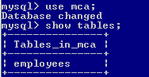

mysql> CREATE TABLE tr (id INT, name VARCHAR(50), purchased DATE)

PARTITION BY RANGE( YEAR(purchased) ) (

PARTITION p0 VALUES LESS THAN (1990),

PARTITION p1 VALUES LESS THAN (1995),

PARTITION p2 VALUES LESS THAN (2000),

PARTITION p3 VALUES LESS THAN (2005),

PARTITION p4 VALUES LESS THAN (2010),

PARTITION p5 VALUES LESS THAN (2015)

);

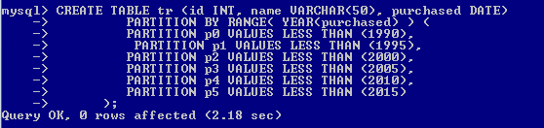

Above code simply create a table named as tr with three columns and 6 partitions on which values are defined inside brackets i.e ().

Now insert data as rows into employees table with following queries.

Mysql> INSERT INTO tr VALUES

(1, 'desk organiser', '2003-10-15'),

(2, 'alarm clock', '1997-11-05'),

(3, 'chair', '2009-03-10'),

(4, 'bookcase', '1989-01-10'),

(5, 'exercise bike', '2014-05-09'),

(6, 'sofa', '1987-06-05'),

(7, 'espresso maker', '2011-11-22'),

(8, 'aquarium', '1992-08-04'),

(9, 'study desk', '2006-09-16'),

(10, 'lava lamp', '1998-12-25');

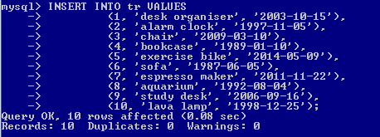

Now check the inserted data with select statement.

Mysql> select * from tr;

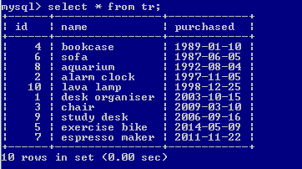

We can also check the inserted data into table tr with partition with range created with following code.

Mysql> SELECT * FROM tr PARTITION (p2);

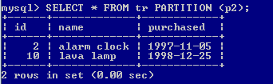

Mysql> SELECT * FROM tr PARTITION (p5);

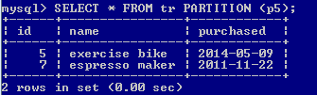

Mysql> SELECT * FROM tr PARTITION (p4);

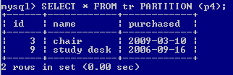

We can also check the data with below select statement.

Mysql> SELECT PARTITION_NAME, TABLE_ROWS FROM INFORMATION_SCHEMA.PARTITIONS WHERE TABLE_NAME='tr';

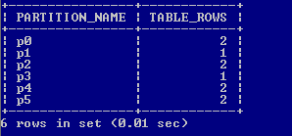

**Drop a MySQL partition**

If you feel some data are useless in a partitioned table you can drop one or more partition(s). To delete all rows from partition p0 of tr, you can use the following statement:

MySQL> ALTER TABLE tr TRUNCATE PARTITION p0;

Mysql> SELECT PARTITION_NAME, TABLE_ROWS FROM INFORMATION_SCHEMA.PARTITIONS WHERE TABLE_NAME='tr';

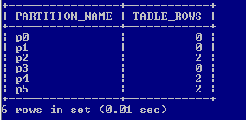

**1b. Implementation of Data partitioning through List partition.**

### MySQL LIST Partitioning

It is the same as Range Partitioning. Here, the partition is defined and selected based on columns matching one of a set of discrete value lists rather than a set of a contiguous range of values. It is performed by the **PARTITION BY LIST(exp)** clause. The exp is an expression or column value that returns an integer value. The VALUES IN(value_lists) statement will be used to define each partition.

In the below example, suppose we have 12 stores distributed among four franchises based on their region. The table explains it more clearly:

| **Region** | **Store ID Number** |
| --- | --- |
| East | 101, 103, 105 |
| West | 102, 104, 106 |
| North | 107, 109, 111 |
| South | 108, 110, 112 |

We can partition the above table where rows for stores belonging to the same region and will be stored in the same partition. The following statement arranges the stores in the same region using LIST partitioning, as shown below:

Mysql> CREATE TABLE Stores (

    cust_name VARCHAR(40),

    bill_no VARCHAR(20) NOT NULL,

    store_id INT PRIMARY KEY NOT NULL,

    bill_date DATE NOT NULL,

    amount DECIMAL(8,2) NOT NULL

)

PARTITION BY LIST(store_id) (

PARTITION pEast VALUES IN (101, 103, 105),

PARTITION pWest VALUES IN (102, 104, 106),

PARTITION pNorth VALUES IN (107, 109, 111),

PARTITION pSouth VALUES IN (108, 110, 112));

**Module 2**

**OLAP with Oracle**

**Aim :ANALYTICAL QUERIES**

**Implementation of Analytical queries like Roll_UP, CUBE, First, Last, Rank AND Dense Rank.**

**Concept:**

The last decade has seen a tremendous increase in the use of query, reporting, and on-line analytical processing (OLAP) tools, often in conjunction with data warehouses and data marts. Enterprises exploring new markets and facing greater competition expect these tools to provide the maximum possible decision-making value from their data resources.

Oracle expands its long-standing support for analytical applications in Oracle8i release 8.1.5 with the CUBE and ROLLUP extensions to SQL. Oracle also provides optimized performance and simplified syntax for Top-N queries. These enhancements make important calculations significantly easier and more efficient, enhancing database performance, scalability and simplicity.

ROLLUP and CUBE are simple extensions to the SELECT statement's GROUP BY clause. ROLLUP creates subtotals at any level of aggregation needed, from the most detailed up to a grand total. CUBE is an extension similar to ROLLUP, enabling a single statement to calculate all possible combinations of subtotals.

**Syntax-**

ROLLUP appears in the GROUP BY clause in a SELECT statement. Its form is:

SELECT ... GROUP BY

ROLLUP(grouping_column_reference_list)

Example:

select empno,sal, sum(sal) as Totalsal from emp group by rollup(sal);

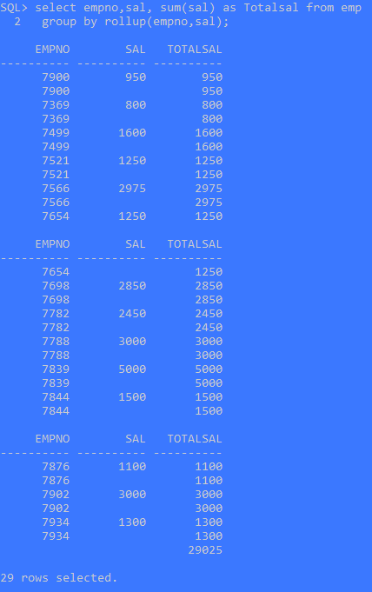

CUBE can generate the information needed in cross-tab reports with a single query. To enhance performance, both CUBE and ROLLUP are parallelized: multiple processes can simultaneously execute both types of statements.

CUBE appears in the GROUP BY clause in a SELECT statement. Its form is:

**Syntax-**

SELECT ... GROUP BY

CUBE (grouping_column_reference_list)

Example:

select empno,sal, sum(sal) as Totalsal from emp group by cube(sal);

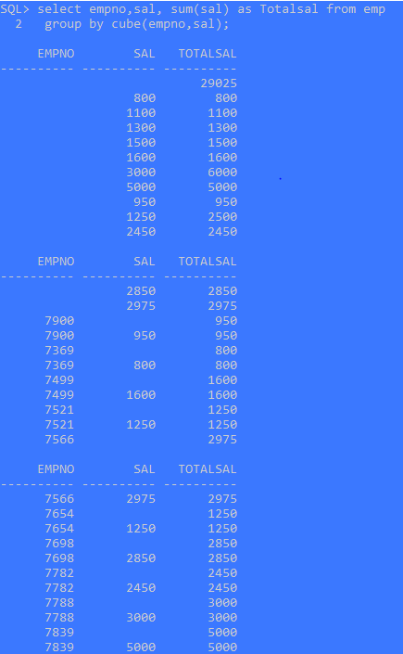

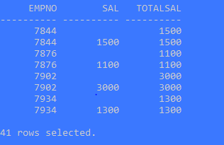

With analytic queries, **we can combine data from multiple queries from the same or differing data sources into one result set**.

In some situations, we may need to draw data from several different sets of data, some of which might be stored in different data sources.

An analytic function **computes values over a group of rows and returns a single result for each row**.

Example: we will create a tables named as EMP as follows.

CREATE TABLE emp (

empno NUMBER(4) CONSTRAINT pk_emp PRIMARY KEY,

ename VARCHAR2(10),

job VARCHAR2(9),

mgr NUMBER(4),

hiredate DATE,

sal NUMBER(7,2),

comm NUMBER(7,2),

deptno NUMBER(2)

);

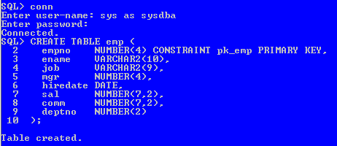

**RANK**

RANK() OVER ([ query_partition_clause ] order_by_clause)

Let's assume we want to assign a sequential order, or rank, to people within a department based on salary, we might use the RANK function like this.

SELECT empno,

deptno,

sal,

RANK() OVER (PARTITION BY deptno ORDER BY sal) AS myrank

FROM emp;

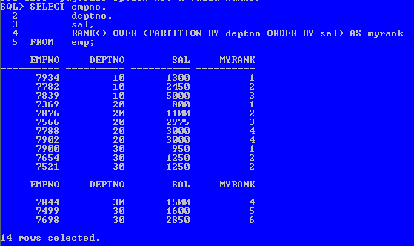

What we see here is where two people have the same salary they are assigned the same rank. When multiple rows share the same rank the next rank in the sequence is not consecutive. This is like olympic medaling in that if two people share the gold, there is no silver medal etc.

The fact we can rank the rows in the department means we are able to do a [Top-N query](https://oracle-base.com/articles/misc/top-n-queries) on a per-department basis. The example below assigns the rank in the inline view, then uses that rank to restrict the rows to the bottom 2 (worst paid) employees in each department.

SELECT *

FROM (SELECT empno,

deptno,

sal,

RANK() OVER (PARTITION BY deptno ORDER BY sal) AS myrank

FROM emp)

WHERE myrank <= 2;

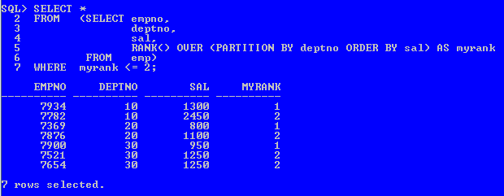

**DENSE_RANK**

The basic description for the DENSE_RANK analytic function is shown below. The analytic clause is described below.

DENSE_RANK() OVER([ query_partition_clause ] order_by_clause)

The DENSE_RANK function acts like the RANK function except that it assigns consecutive ranks, so this is not like olympic medaling.

SELECT empno,

deptno,

sal,

DENSE_RANK() OVER (PARTITION BY deptno ORDER BY sal) AS myrank

FROM emp;

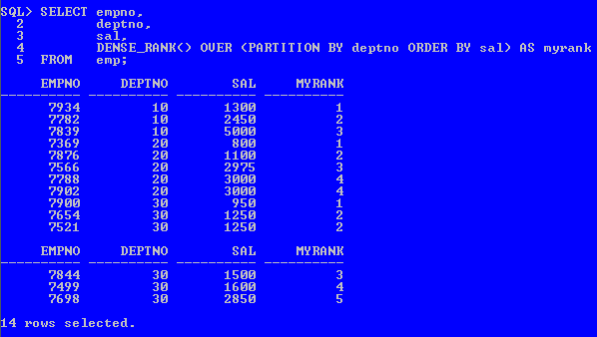

As with the RANK analytic function, we can do a [Top-N query](https://oracle-base.com/articles/misc/top-n-queries) on a per-department basis. The example below assigns the dense rank in the inline view, then uses that rank to restrict the rows to the top 2 (best paid) employees in each department.

SELECT *

FROM (SELECT empno,

deptno,

sal,

DENSE_RANK() OVER (PARTITION BY deptno ORDER BY sal DESC) AS myrank

FROM emp)

WHERE myrank <= 2;

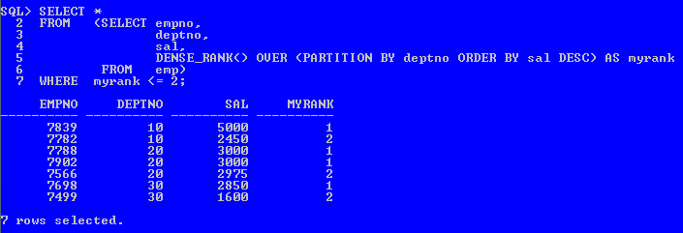

## FIRST and LAST

Most of the time I find myself using [FIRST_VALUE and LAST_VALUE Analytic Functions](https://oracle-base.com/articles/misc/first-value-and-last-value-analytic-functions) in preference to FIRST and LAST. Pick which feels best for your use case.

The FIRST and LAST functions can be used to return the first or last value from an ordered sequence. Say we want to display the salary of each employee, along with the lowest and highest within their department we may use something like.

SELECT empno,

deptno,

sal,

MIN(sal) KEEP (DENSE_RANK FIRST ORDER BY sal) OVER (PARTITION BY deptno) AS lowest,

MAX(sal) KEEP (DENSE_RANK LAST ORDER BY sal) OVER (PARTITION BY deptno) AS highest

FROM emp

ORDER BY deptno, sal;

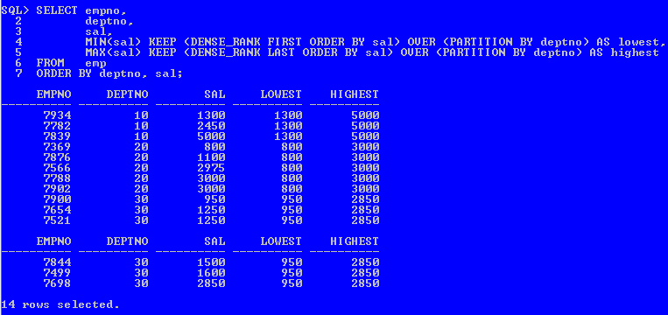

The MIN and MAX functions are almost irrelevant here as it's FIRST, LAST and KEEP that are picking the row whose value will be used. We can demonstrate this by using MIN for both the high and low value.

SELECT empno,

deptno,

sal,

MIN(sal) KEEP (DENSE_RANK FIRST ORDER BY sal) OVER (PARTITION BY deptno) AS lowest,

MIN(sal) KEEP (DENSE_RANK LAST ORDER BY sal) OVER (PARTITION BY deptno) AS highest

FROM emp

ORDER BY deptno, sal;

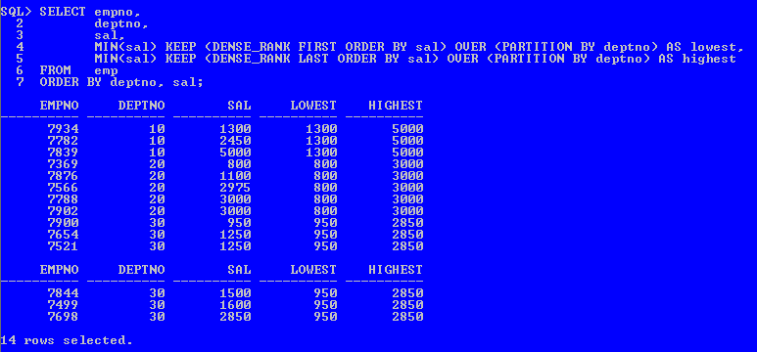

We get the same result.

We could also achieve the same result using FIRST_VALUE and LAST_VALUE, or MIN and MAX as basic analytic functions. In practice I don't use FIRST and LAST very often.

## LAG

## The LAG function is used to access data from a previous row. The following query returns the salary from the previous row to calculate the difference between the salary of the current row and that of the previous row. Notice that the ORDER BY of the LAG function is used to order the data by salary.

SELECT empno,

ename,

job,

sal,

LAG(sal, 1, 0) OVER (ORDER BY sal) AS sal_prev,

sal - LAG(sal, 1, 0) OVER (ORDER BY sal) AS sal_diff

FROM emp;

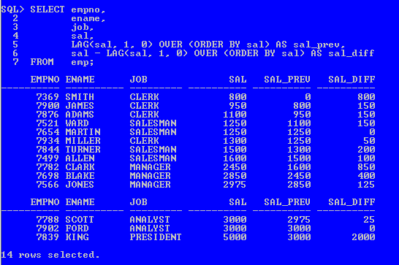

If the LAG would span a partition boundary, the default value is returned. In the following example we partition by department, so the SAL_PREV column has a default value of "0" for the first row in each department.

SELECT deptno,

empno,

ename,

job,

sal,

LAG(sal, 1, 0) OVER (PARTITION BY deptno ORDER BY sal) AS sal_prev

FROM emp;

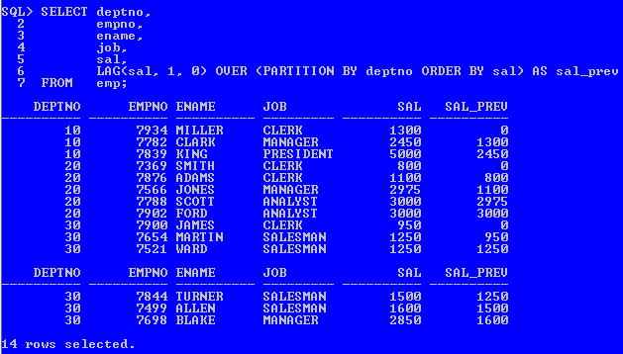

## LEAD

The LEAD function is used to return data from rows further down the result set. The following query returns the salary from the next row to calculate the difference between the salary of the current row and the following row.

SELECT empno,

ename,

job,

sal,

LEAD(sal, 1, 0) OVER (ORDER BY sal) AS sal_next,

LEAD(sal, 1, 0) OVER (ORDER BY sal) - sal AS sal_diff

FROM emp;

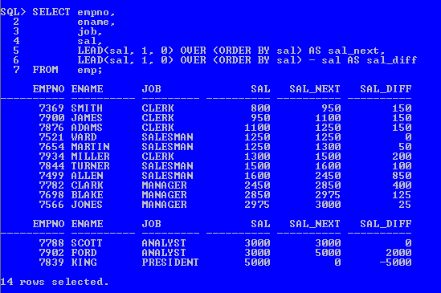

If the LEAD would span a partition boundary, the default value is returned. In the following example we partition by department, so the SAL_NEXT column has a default value of "0" for the last row in each department.

SELECT deptno,

empno,

ename,

job,

sal,

LEAD(sal, 1, 0) OVER (PARTITION BY deptno ORDER BY sal) AS sal_next

FROM emp;

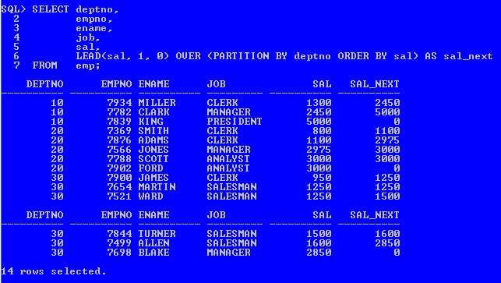

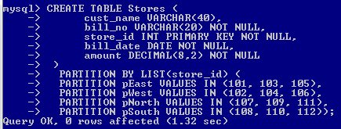

**Module 3**

ORDBMS

**Aim: Implementation of Abstract Data Type & Reference**

**Creating Tables Under the Relational Model**

The relational approach normalizes everything into tables. The table names are Customer_reltab, PurchaseOrder_reltab, and Stock_reltab.

Each part of an address becomes a column in the Customer_reltab table. Structuring telephone numbers as columns sets an arbitrary limit on the number of telephone numbers a customer can have.

The relational approach separates line items from their purchase orders and puts each into its own table, named PurchaseOrder_reltab and LineItems_reltab.

The relational approach results in the tables describe in the following sections.

#### **Customer_reltab**

The Customer_reltab table has the following definition:

CREATE TABLE Customer_reltab (

CustNo NUMBER NOT NULL,

CustName VARCHAR2(200) NOT NULL,

Street VARCHAR2(200) NOT NULL,

City VARCHAR2(200) NOT NULL,

State CHAR(2) NOT NULL,

Zip VARCHAR2(20) NOT NULL,

Phone1 VARCHAR2(20),

Phone2 VARCHAR2(20),

Phone3 VARCHAR2(20),

PRIMARY KEY (CustNo));

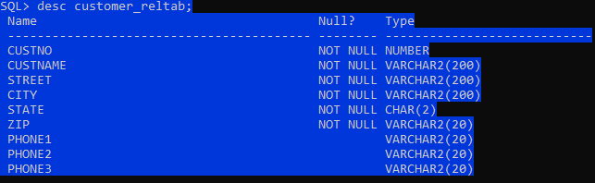

This table, Customer_reltab, stores all the information about customers, which means that it fully contains information that is intrinsic to the customer (defined with the NOT NULL constraint) and information that is not as essential. According to this definition of the table, the application requires that every customer have a shipping address.

#### **PurchaseOrder_reltab**

#### The PurchaseOrder_reltab table has the following definition:

CREATE TABLE PurchaseOrder_reltab (

PONo NUMBER, /* purchase order no */

Custno NUMBER references Customer_reltab, /* Foreign KEY referencing

customer */

OrderDate DATE, /* date of order */

ShipDate DATE, /* date to be shipped */

ToStreet VARCHAR2(200), /* shipto address */

ToCity VARCHAR2(200),

ToState CHAR(2),

ToZip VARCHAR2(20),

PRIMARY KEY(PONo));

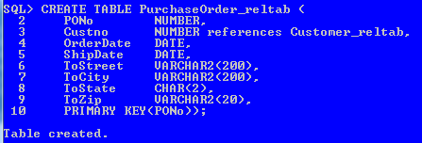

PurchaseOrder_reltab manages the relationship between the customer and the purchase order by means of the foreign key (FK) column CustNo, which references the CustNo key of the Customer_reltab. The PurchaseOrder_reltab table contains no information about related line items. The line items table (next section) uses the purchase order number to relate a line item to its parent purchase order.

#### **Stock_reltab**

The Stock_reltab table has the following definition:

CREATE TABLE Stock_reltab (

StockNo NUMBER PRIMARY KEY,

Price NUMBER,

TaxRate NUMBER);

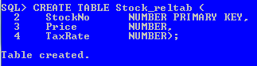

**LineItems_reltab**

The LineItems_reltab table has the following definition:

CREATE TABLE LineItems_reltab (

LineItemNo NUMBER,

PONo NUMBER REFERENCES PurchaseOrder_reltab,

StockNo NUMBER REFERENCES Stock_reltab,

Quantity NUMBER,

Discount NUMBER,

PRIMARY KEY (PONo, LineItemNo));

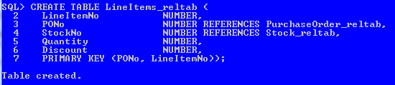

The table name is in the plural form LineItems_reltab to emphasize to someone reading the code that the table holds a collection of line items.

PONo, which references the PONo column in PurchaseOrder_reltab

StockNo, which references the StockNo column in Stock_reltab

**Inserting Values Under the Relational Model**

In our application, statements like these insert data into the tables:

INSERT INTO Stock_reltab VALUES(1004, 6750.00, 2);

INSERT INTO Stock_reltab VALUES(1011, 4500.23, 2);

INSERT INTO Stock_reltab VALUES(1534, 2234.00, 2);

INSERT INTO Stock_reltab VALUES(1535, 3456.23, 2);

INSERT INTO Customer_reltab

VALUES (1, 'Jean Nance', '2 Avocet Drive',

'Redwood Shores', 'CA', '95054',

'415-555-1212', NULL, NULL);

INSERT INTO Customer_reltab

VALUES (2, 'John Nike', '323 College Drive',

'Edison', 'NJ', '08820',

'609-555-1212', '201-555-1212', NULL);

INSERT INTO PurchaseOrder_reltab

VALUES (1001, 1, SYSDATE, '10-MAY-1997',

NULL, NULL, NULL, NULL);

INSERT INTO PurchaseOrder_reltab

VALUES (2001, 2, SYSDATE, '20-MAY-1997',

'55 Madison Ave', 'Madison', 'WI', '53715');

INSERT INTO LineItems_reltab VALUES(01, 1001, 1534, 12, 0);

INSERT INTO LineItems_reltab VALUES(02, 1001, 1535, 10, 10);

INSERT INTO LineItems_reltab VALUES(01, 2001, 1004, 1, 0);

INSERT INTO LineItems_reltab VALUES(02, 2001, 1011, 2, 1);

**Querying Data Under the Relational Model**

The application can execute queries like these:

SELECT C.CustNo, C.CustName, C.Street, C.City, C.State,

C.Zip, C.phone1, C.phone2, C.phone3,

P.PONo, P.OrderDate,

L.StockNo, L.LineItemNo, L.Quantity, L.Discount

FROM Customer_reltab C,

PurchaseOrder_reltab P,

LineItems_reltab L

WHERE C.CustNo = P.CustNo

AND P.PONo = L.PONo

AND P.PONo = 1001;

**Get the Total Value of Purchase Orders**

SELECT P.PONo, SUM(S.Price * L.Quantity)

FROM PurchaseOrder_reltab P,

LineItems_reltab L,

Stock_reltab S

WHERE P.PONo = L.PONo

AND L.StockNo = S.StockNo

GROUP BY P.PONo;

Get the Purchase Order and Line Item Data for Stock Item 1004

SELECT P.PONo, P.CustNo,

L.StockNo, L.LineItemNo, L.Quantity, L.Discount

FROM PurchaseOrder_reltab P,

LineItems_reltab L

WHERE P.PONo = L.PONo

AND L.StockNo = 1004;

**Updating Data Under the Relational Model. The application can execute statements like these to update the data:**

UPDATE LineItems_reltab

SET Quantity = 20

WHERE PONo = 1001

AND StockNo = 1534;

**Deleting Data Under the Relational Model**

DELETE

FROM LineItems_reltab

WHERE PONo = 1001;

DELETE

FROM PurchaseOrder_reltab

WHERE PONo = 1001;

**Subject Name:** Advanced Database Management System Lab

**Module No: 4**

**Experiment no.1**

**Aim:** To study ETL process.

**Objective:** To understand ETL process in the Data Warehouse.

**Theory:**

* **What is ETL?**

**ETL** is a process that extracts the data from different source systems, then transforms the data (like applying calculations, concatenations, etc.) and finally loads the data into the data Warehouse system.

Before loading into the warehouse, the data is transformed from a raw state into the format required by the enterprise data warehouse.

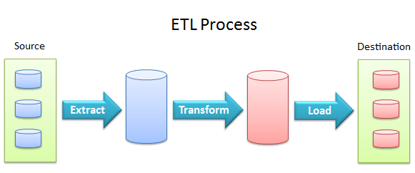

Figure 1: ETL process

**Extract:**

 Itis the process of fetching (reading) the information from the database. At this stage, data is collected from different types of sources.

**Transform:**

It is the process of converting the extracted data from its previous form into the required form. Data can be placed into another database. Transformation can occur by using rules or lookup tables or by combining the data with other data.

**Load:**

Itis the process of writing the data into the target database.

In the ETL process, data is extracted from the multiple source system and converted into a format that can be examined and stored into a **data warehouse** or any other system. It is often used to build a **data warehouse**.

### **Example:**

Let’s take an example of retail store which has different departments like sales, marketing, logistics, etc. Each department is handling the customer's information independently, and the way each department stores the data is quite different.

Sales department stores it by the **customer's name and** marketing department store it by **customer id.**

Now, if we want to check the history of the customer and want to know what different types of products, he/she bought owing to various campaigns; it would be very tedious.

The solution for this is to use a data warehouse to store information from different sources in a uniform structure using ETL. ETL tools extract the data from all these data sources and transform the data (like applying calculations, joining fields, removing incorrect data fields, etc.) and loads into a data warehouse.

ETL can transform unique data sets into a unified structure. After that, we will use BI tools to find out the meaningful reports, dashboards, visualization from this data.

## Need of ETL

There are many reasons the need for ETL is arising:

* ETL helps the companies to analyze their business data for making critical business decisions.
* ETL provides a method of moving data from various sources into a data warehouse. As the data sources change, the data warehouse will automatically update.
* Well-designed and documented ETL system is essential for the success of the data warehouse project.
* For business purpose, ETL offers deep historical context.
* It helps to improve productivity because it is codified and can be reused without a need for technical skills.

The popular ETL tools available in the market are:

* IBM- Websphere DataStage
* Informatica- Power Center
* SAP- Business objects data service BODS
* SAS - Data Integration Studio
* Oracle- Warehouse Builder
* Open source Clover ETL.

References

Figure 1: ETL process- <https://blog.appliedinformaticsinc.com/etl-extract-transform-and-load-process-concept/> , accessed on 14th July 2021.

**Questions:**

1. ETL stands for ____________?

a) Extract, Transfer and Load

b) Extract, Transform and Load

c) Extract, Time and Load

d) Extract, Transform and Loss

**2. Extract is the process of ________________.**

a) adding new data to a database.

b) reading and collecting data from a database, the data is often collected from multiple sources.

c) analyzing collected information

d) none of the above

**3. Load is the process of ___________________.**

a) publishing the data to decision makers.

b) reviewing data in the database.

c)writing data into a RPA tool.

d)writing the data into the target database.

**Subject Name:** Advanced Database Management System Lab

**Module No: 4**

**Experiment no.2**

**Aim:** Installation of Pentaho Software.

**Objective:**

1. Download the Pentaho Data Integration software.

2. Install JRE and JDK.

3. Set up JRE and JDK environment variables for Pentaho Data Integration.

**Theory:**

## Pentaho Data Integration - Kettle ETL tool

Kettle (K.E.T.T.L.E - Kettle ETTL Environment) has been recently acquired by the Pentaho group and renamed to **Pentaho Data Integration**. Kettle is a leading open source ETL application on the market. It is classified as an ETL tool, however the concept of classic ETL process (extract, transform, load) has been slightly modified in Kettle as it is composed of four elements, **ETTL**, which stands for:

* Data **extraction** from source databases
* **Transport** of the data
* Data **transformation**
* **Loading** of data into a data warehouse

Kettle is a set of tools and applications which allows data manipulations across multiple sources.  
The main components of Pentaho Data Integration are:

* **Spoon**–

It is a graphical tool which make the design of an ETTL process transformations easy to create. It performs the typical data flow functions like reading, validating, refining, transforming, writing data to a variety of different data sources and destinations. Transformations designed in Spoon can be run with Kettle Pan and Kitchen.

* **Pan**–

It is an application dedicated to run data transformations designed in Spoon.

* **Chef –**

It is a tool to create jobs which automate the database update process in a complex way.

* **Kitchen –**

It is an application which helps execute the jobs in a batch mode, usually using a schedule which makes it easy to start and control the ETL processing.

* **Carte –**

It is a web server which allows remote monitoring of the running Pentaho Data Integration ETL processes through a web browser.

* **Installation steps for Pentaho Data Integration Software**

**Step 1: Download Pentaho Data Integration Software.**

The first thing we need is the Pentaho Data Integration software that we’ll be working with.

You can download the set up file from

link <https://sourceforge.net/projects/pentaho/>.

The page will look something like this:

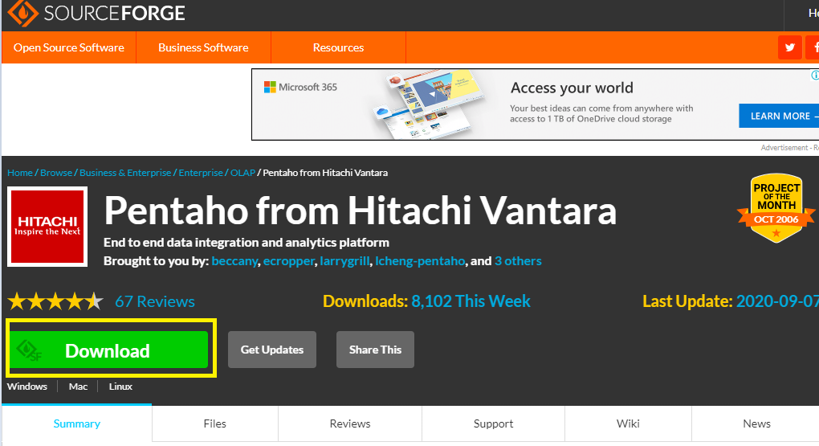

Press the **“Download”** button. It will start downloading zip file on your computer.

Once the downloading is finished, extract the files into a folder you want to.

Your folder should look something like this:

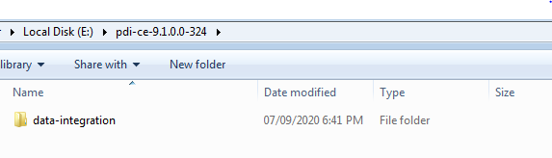

**Step 2: Install the Java Dependencies, if Required.**

To run Pentaho Data Integration, Java Runtime Environment and Java Development Kit are required.

To check if you already have these installed, go to this path in your file explorer:

C:\Program Files\Java

Or: C:\Program Files (x86)\Java

If this folder exists and you see folders that look like:

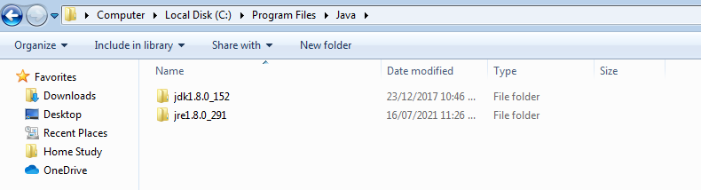

Then you have the required files.

If this folder doesn’t exist or you don’t see one or both of these folders, then you need to download JRE and/or JDK. To download JRE, go to this link <https://java.com/en/download/> and press “Download.”

Your page should look like this:

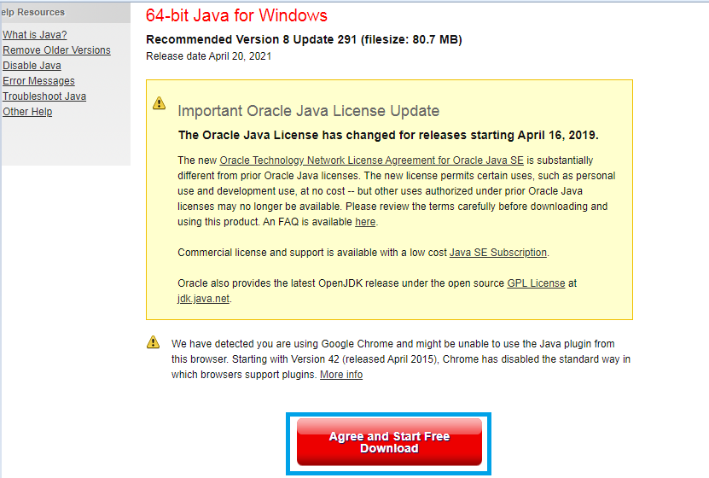

The installation window will look something like this:

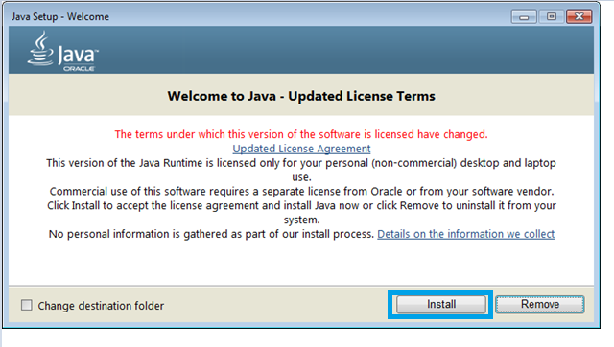

Follow the instructions until finished.

Next, download the JDK from this link <https://www.oracle.com/java/technologies/javase/javase-jdk8-downloads.html>.

Please note that there have been substantial changes to the Oracle JDK licensing agreement. Details are available at Oracle Technology Network License Agreement for Oracle Java SE.

There will be a list of different operating systems to choose from. Scroll until you find Windows.

If you’re unsure about which version (x64 or x86) your Windows is, select x86.

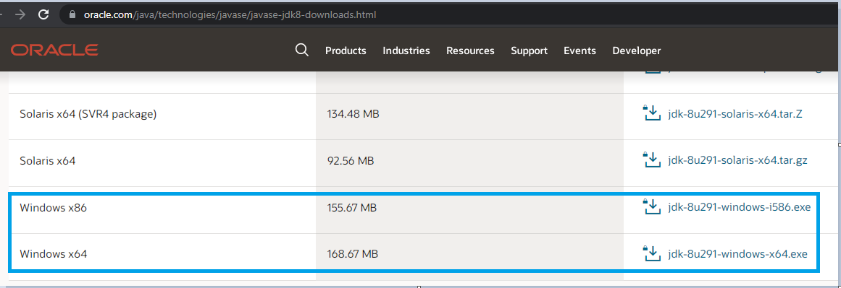

It will open following window.

Press “Download”.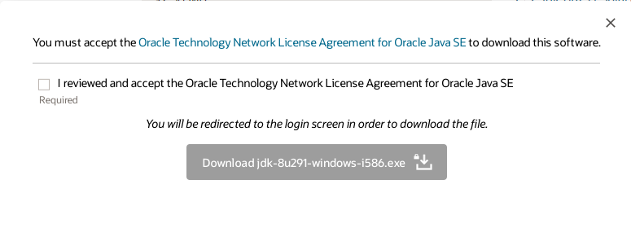

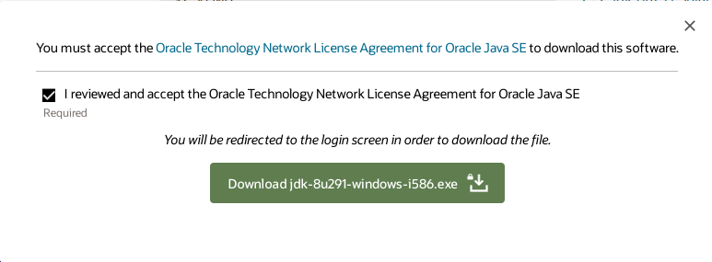

If you’re not logged in to Oracle, then you will be prompted to log in.

If you don’t have an Oracle account, you need to create one in order to download the JDK.

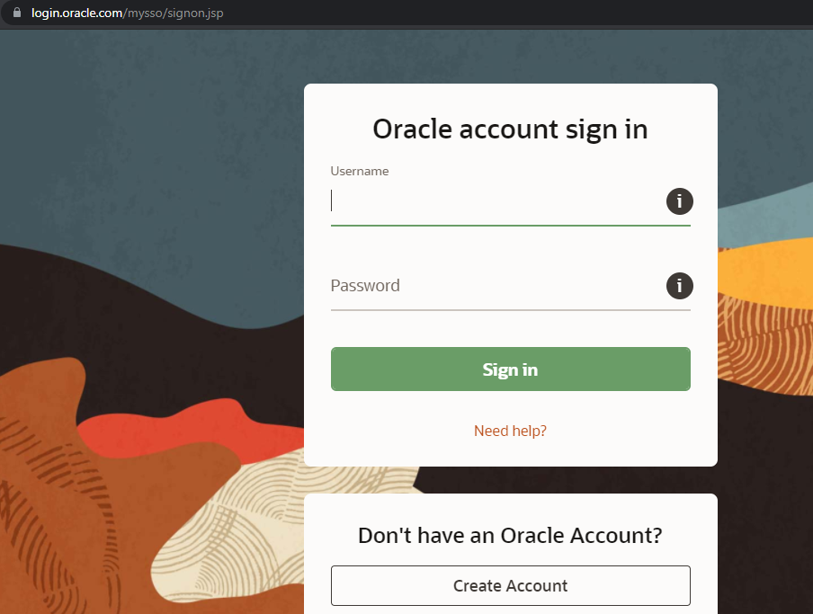

The installation setup will look like this:

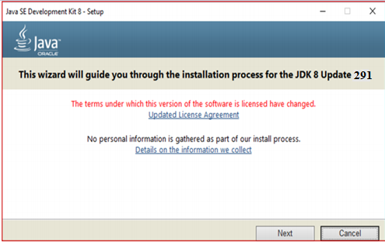

**Graphics:**

Hitachi Video Management Platform (VMP) has been designed from the ground up to meet the challenges of data storage and processing that new video systems present.

**Step 3: Set Up the Environment Variables**

There are three environment variables that need to be set up.

To open the environment variables menu type in “environment variables” in the Windows search bar like this:

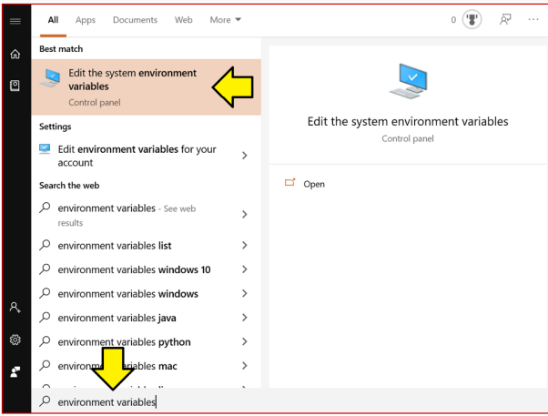

Click the “Edit the system environment variables” option.

That will open the “System Properties” window.

Under Advanced tab …Click the “Environment Variables.” button at the bottom.

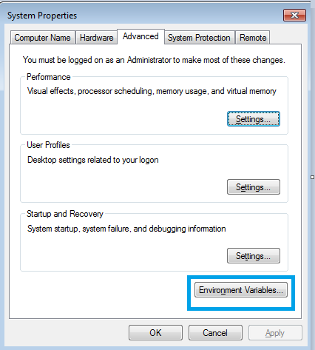

That will open a window that looks like this:

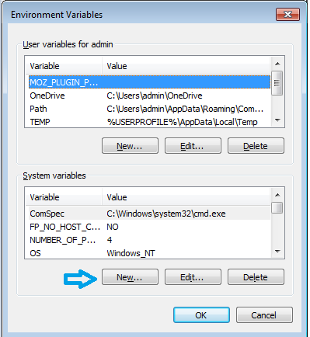

We need to add three new System variables.

Click the “New…” button under “System variables” and enter the following:

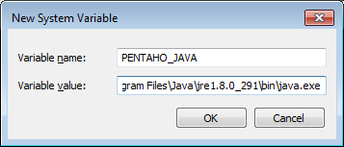

___________________________________________________________________________

**Note:**



____________________________________________________________________________

Make sure your variable value file path is the same one on your computer.

Press “OK” and then enter two more.

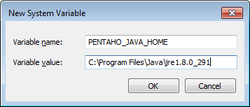

Press ‘’OK’’.

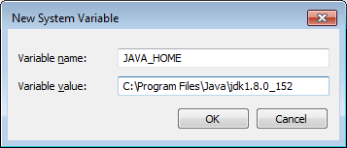

Press ‘’OK’’ and close all the previous windows by pressing “OK.”

**Step 4: Open the Pentaho Data Integration App**

Now that Java is installed successfully and the environment variables are also set, we can start running the Pentaho Data Integration app.

The data integration folder that you downloaded earlier will look like this:

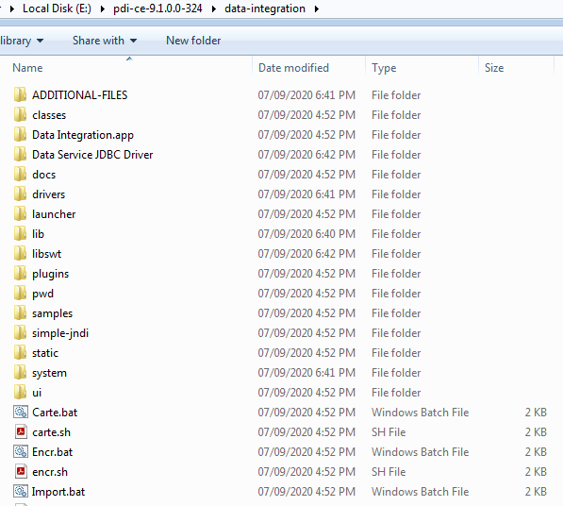

The file that runs the app is called “Spoon.bat”.

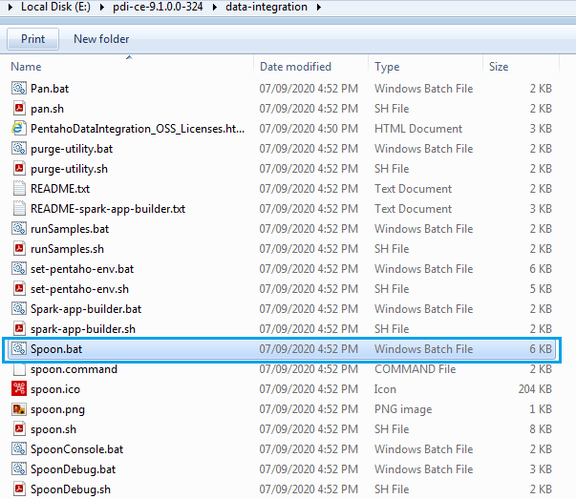

Double click this file to open the Pentaho Data Integration app.

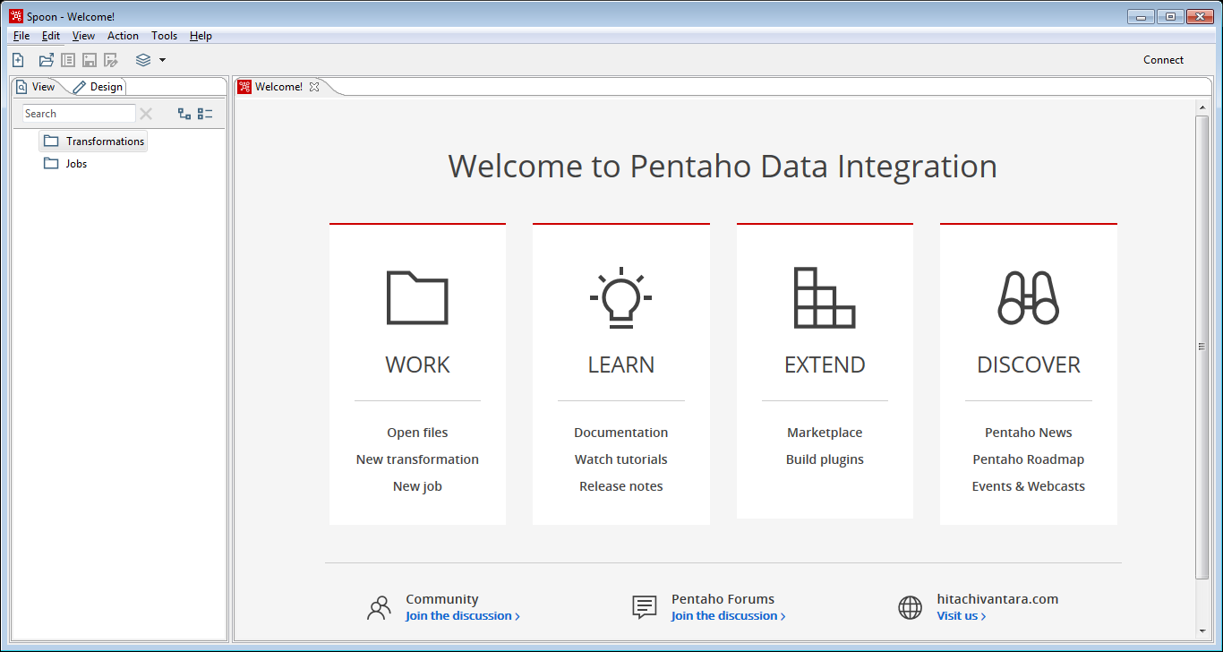

Now you can start using this app by pressing “New transformation” or “New job.”

**Questions:**

1. GUI Provided by Pentaho to design Transformation and Jobs that can be run with Kettle Tools is ___________.

a) Pan b) Kitchen c) Spoon d) No GUI provided

1. Tool which performs reading, manipulating and writing various data sources is called _______.

a) Spoon b) Kitchen c) Kettle d) Pan

3. The program that execute jobs that are designed in Pentaho Data Integration Tools is

a) Kettle b) Kitchen c) ETTL d) Pan

**Subject Name:** Advanced Database Management System Lab

**Module No: 4**

**Experiment no.3**

**Aim:** Extract and load data using Pentaho Data integration tool.

**Objective:** Demonstration of how to build a data integration transformation and a job using the features and tools provided by Pentaho Data Integration (PDI).

**Theory:**

The Data Integration perspective of PDI (also called Spoon) allows us to create two basic file types: **transformations and jobs.**

**Transformations** describe the data flows for ETL such as reading from a source, transforming data and loading it into a target location.

**Jobs** coordinate ETL activities such as defining the flow and dependencies for what order transformations should be run, or prepare for execution by checking conditions such as, "Is my source file available?" or "Does a table exist in my database?"

We will learn basic concepts and processes involved in building a transformation with PDI in a typical business scenario. In this scenario, you are loading a flat file (.CSV) of **sales data** into a database so that mailing lists can be generated.

**Extract and load data**

We will retrieve data from a **.CSV flat file** and use the Text File Input step to: connect to a repository, view the file schema, and retrieve the data contents.

* **Create a new transformation**

Follow these steps to create a new transformation.

1. Select File **New Transformation** in the upper left corner of the PDI window.

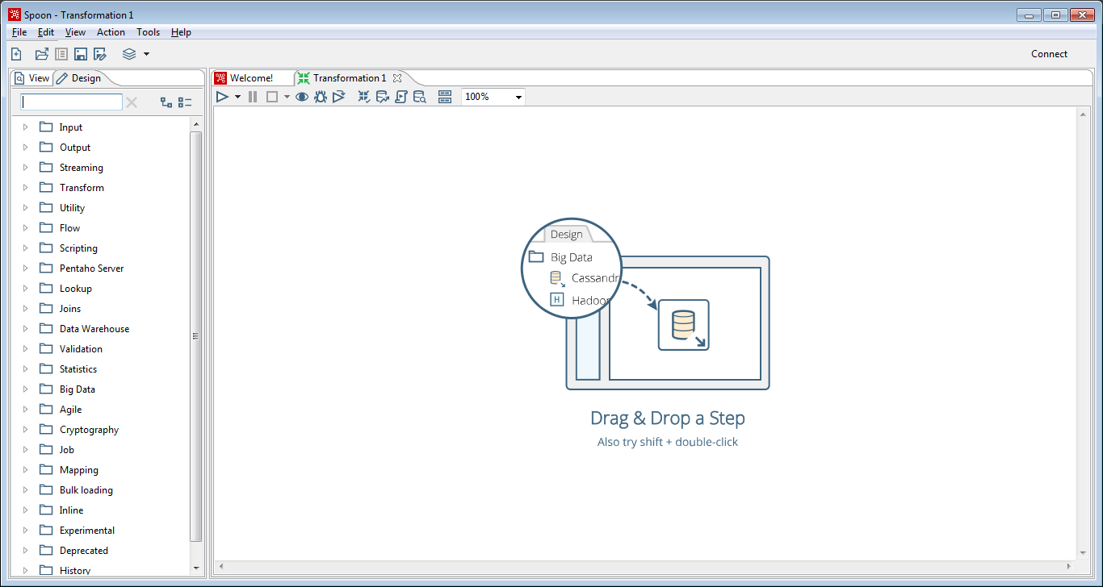

1. Under the **Design tab**, expand the **Input node**, then select and drag a **Text File Input** step onto the canvas.

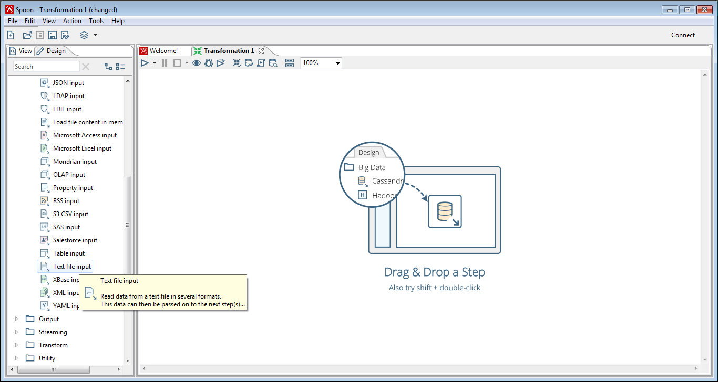

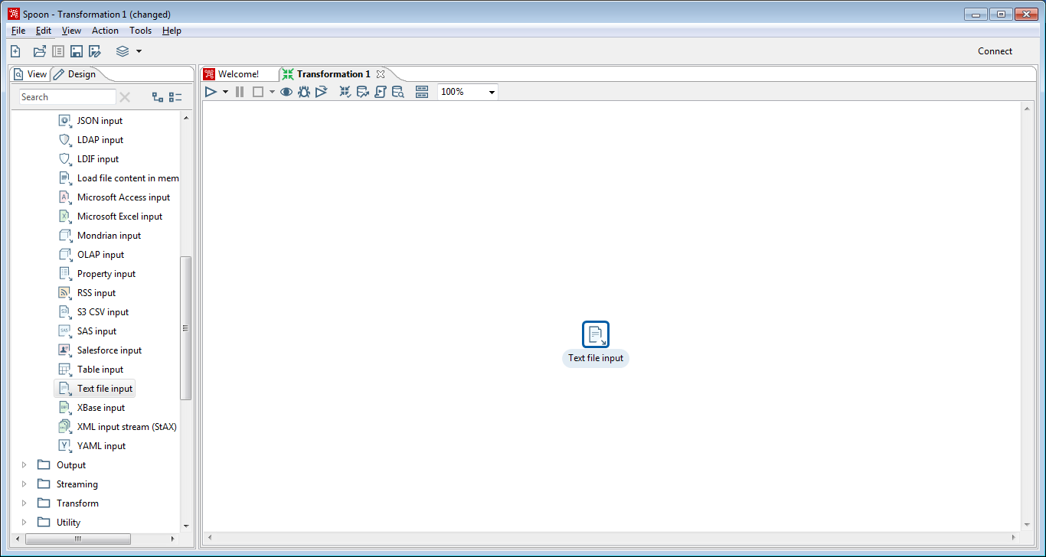

1. Double-click the **Text File input** step. It will open following window.

you can set the step's various properties.

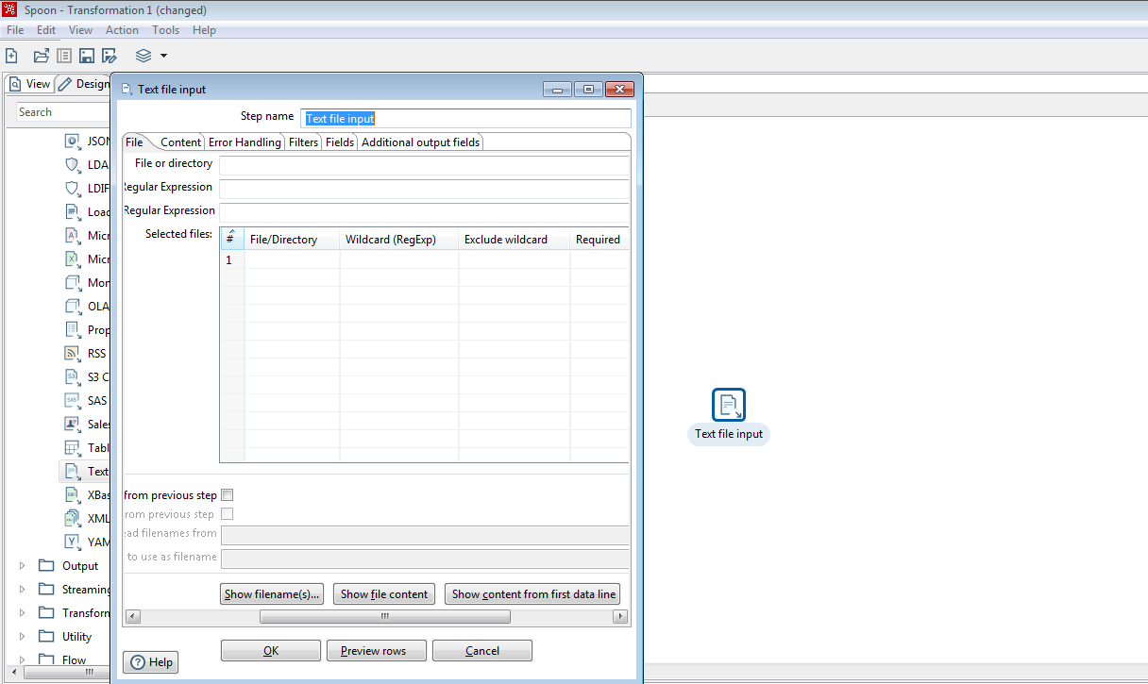

1. Now, In **Step Name field**, type **Read Sales Data.** The **Step name:** **Text file input** step is now renamed to **Read Sales Data.**

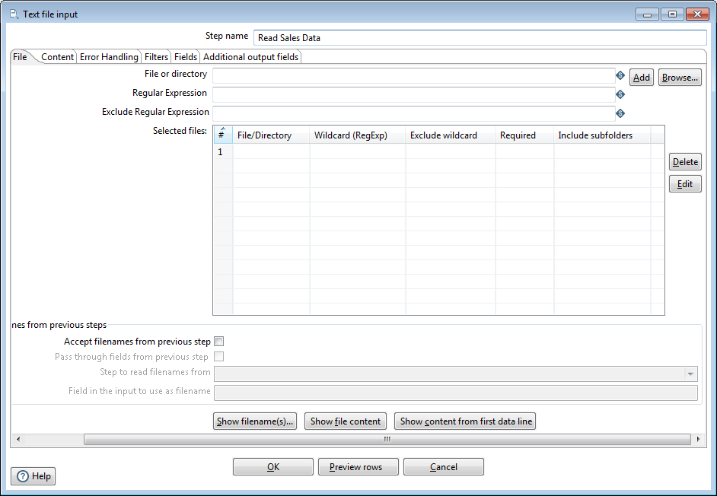

1. Click Browse to locate the source file, **sales_data.csv**, in the E:\datasets\sales_data.csv. The Browse button appears in the top right side of the window near the File or Directory field.
2. Change File type to *.csv. Select sales_data.csv, then click OK​.

The path to the source file appears in the File or directory field.

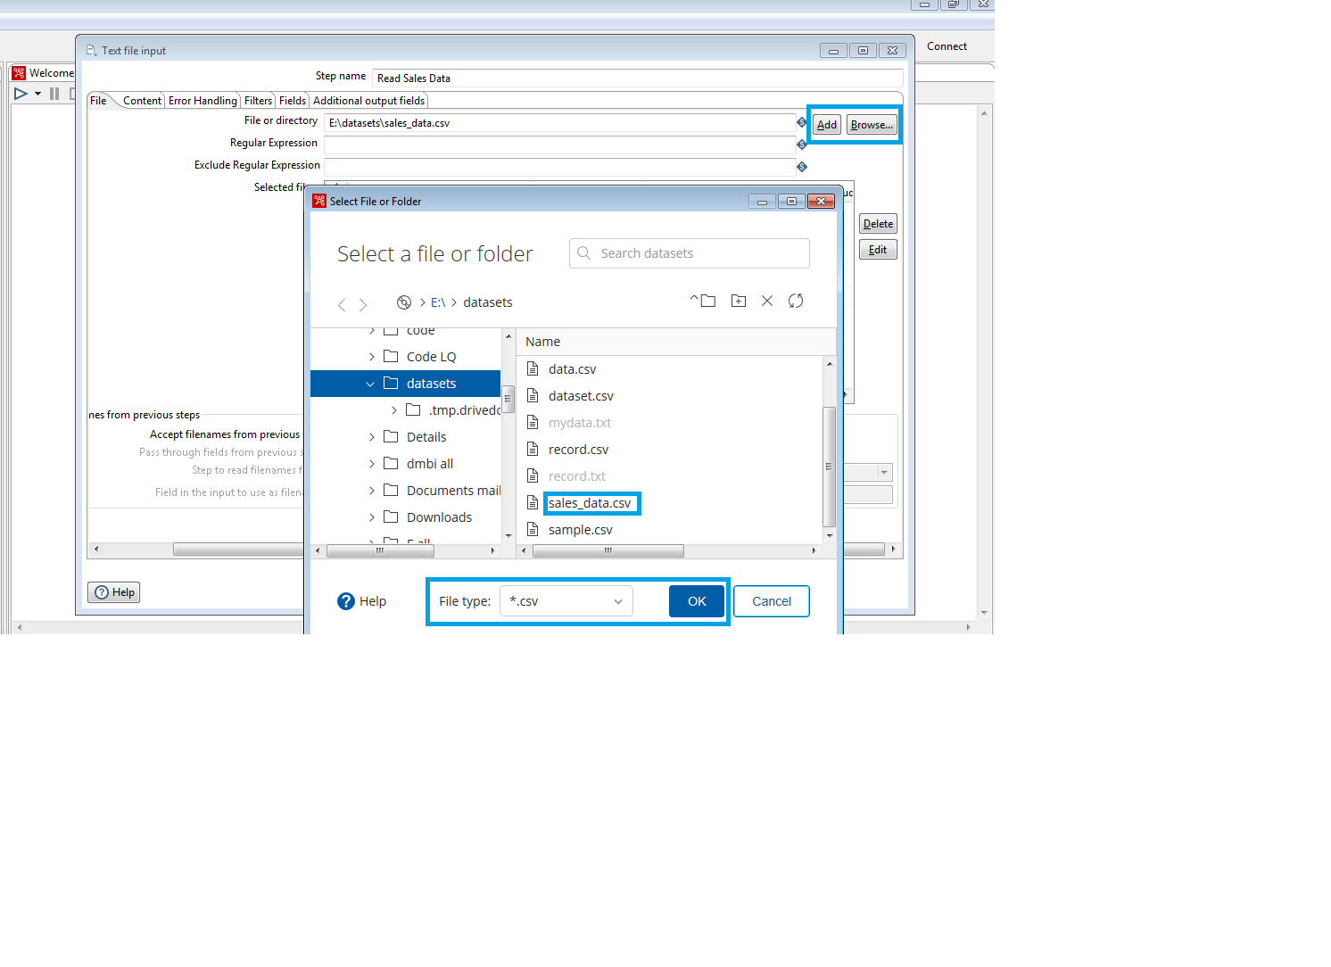

1. Click **Add.** The path to the file appears under Selected Files.

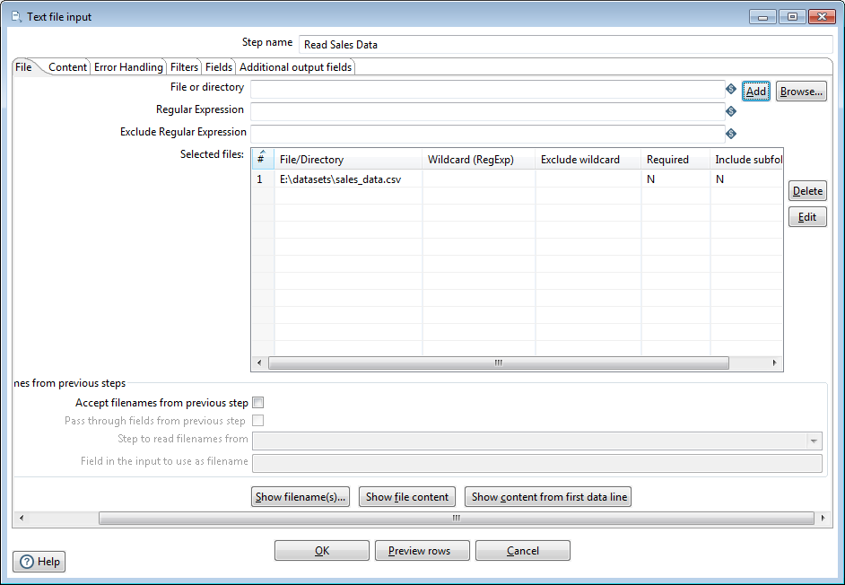

* **View the content in the sample file**

Follow these steps to look at the contents of the sample file.

1. Click the **Content tab**, then set the **Format** field to **Unix**​.
2. Click the **File** tab again and click the **Show file content** near the bottom of the window.
3. The **Number of lines (0-all lines)** window appears. Click the **OK** button to accept the default.
4. The **Content of first file** window displays the file. Examine the file to see how that input file is delimited, what enclosure character is used, and whether or not a header row is present.

In the sample, the input file is comma delimited, the enclosure character being a quotation mark (") and it contains a single header row containing field names.

1. Click the **Close** button to close the window.

**Edit and save the transformation**

Follow these steps to provide information about the data's content.

1. Click the **Content** tab. The fields under the **Content** tab allow you to define how your data is formatted.
2. Verify that the **Separator** is set to **comma** (,) and the **Enclosure** is set to **quotation mark** ("). **Enable Header** because there is one line of header rows in the file and set the **Format field to Unix​**.

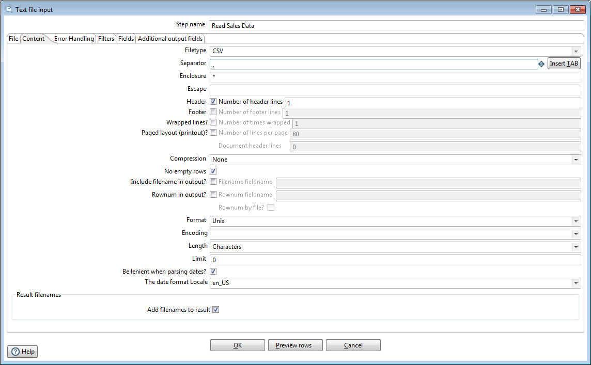

1. Click the **Fields**tab and click **Get Fields** to retrieve the input fields from your source file. When the **Number of lines** to sample window appears, enter **0** in the field then click **OK**.

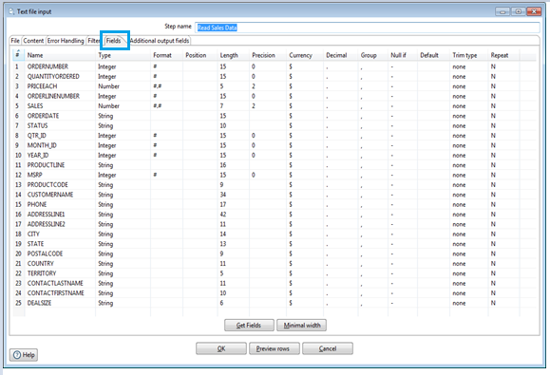

1. If the **Scan Result** window displays, click **Close** to close the window.
2. To verify that the data is being read correctly, click the **Content tab**, then click **Preview rows.**
3. In the Enter the number of rows you would like to preview window, click OK to accept the default.

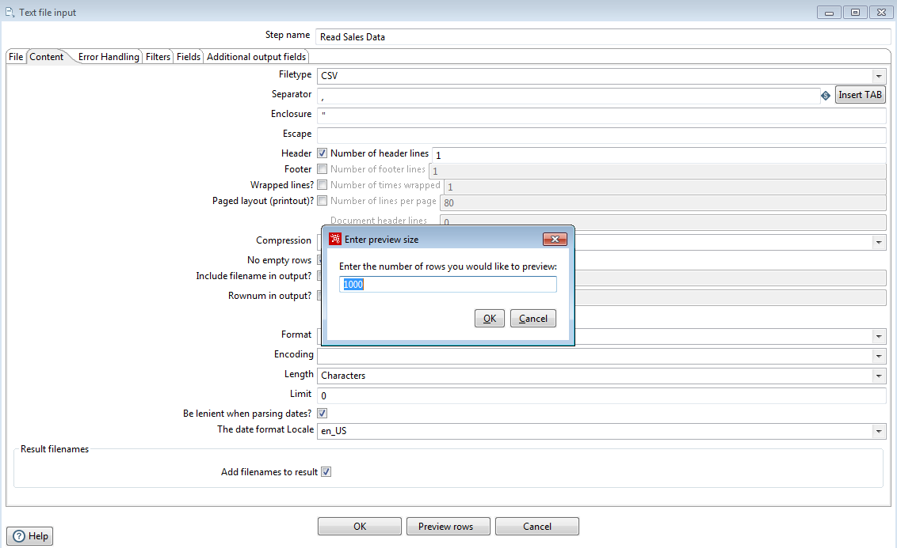

The Examine preview data window appears.

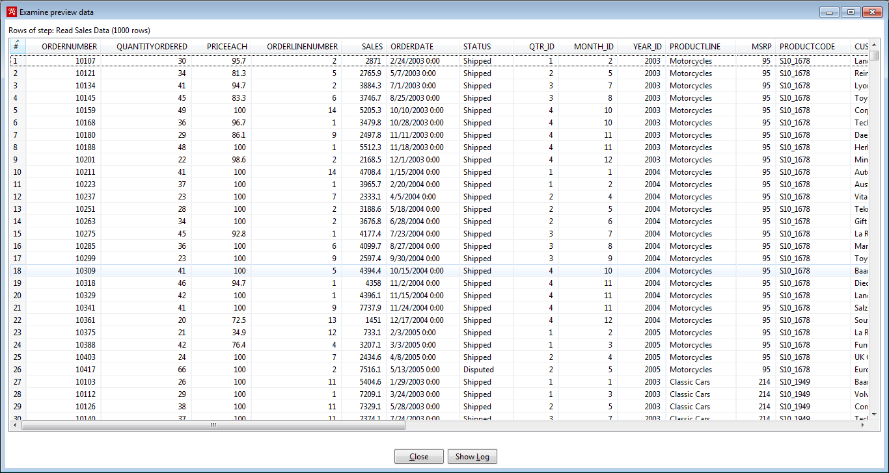

1. Review the data. Do you notice any missing, incomplet, or variations of the data?

ADDRESSLINE2, STATE & POSTALCODE contains <null> value.

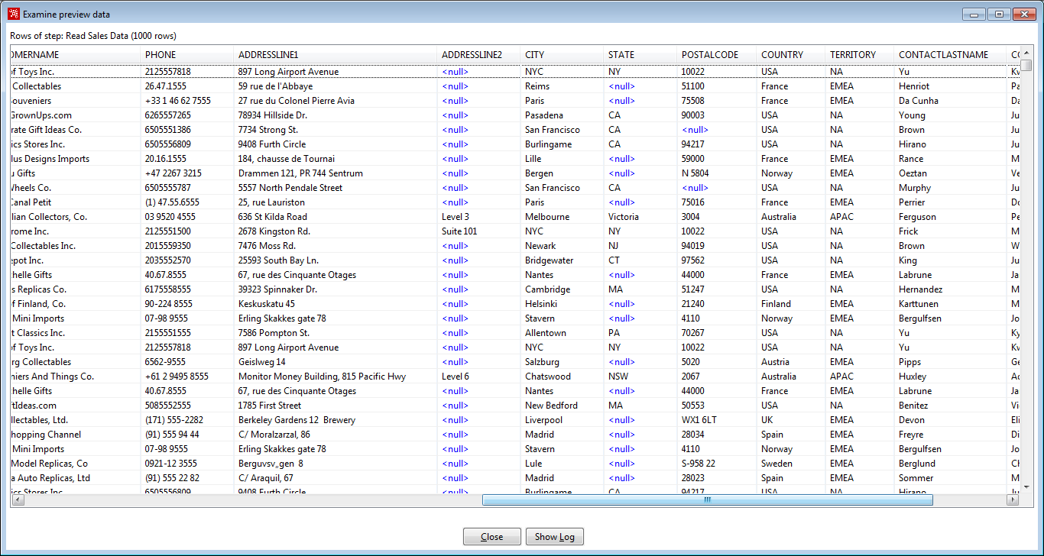

1. Click **Close** to Examine preview data window. Click **OK** to save the information that you entered in the step i.e **Text file input** window.

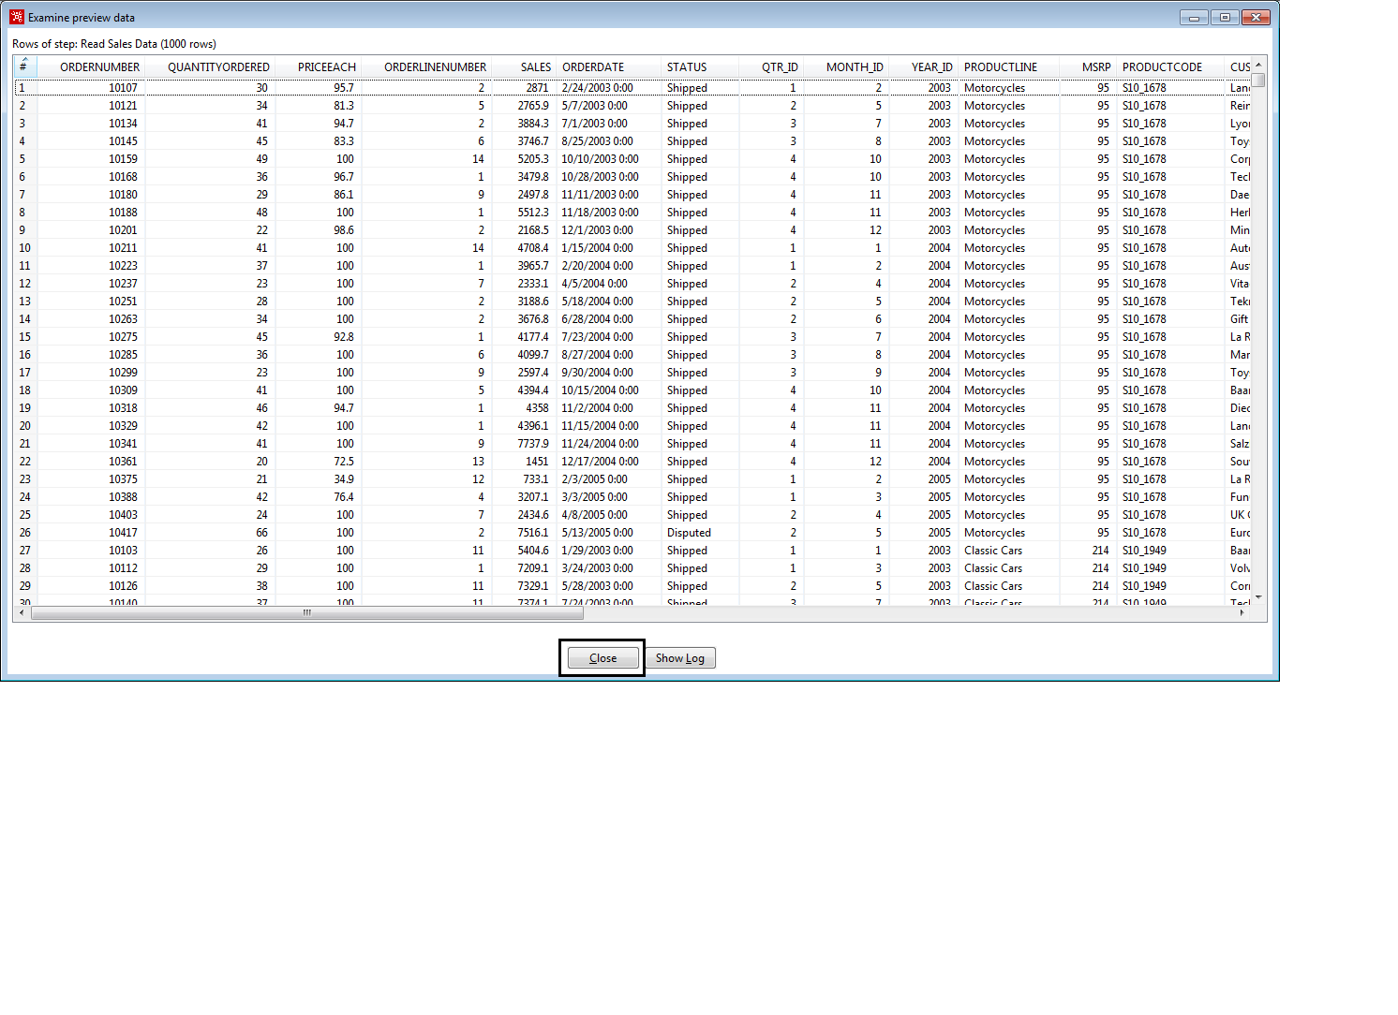

1. Give the transformation a name and provide additional properties using the Transformation Properties window. There are multiple ways to open the Transformation Properties window.
   1. Right-click on any empty space on the canvas and select properties.
   2. Double-click on any empty space on the canvas to select properties.
2. In the **Transformation Name** field, type: **Getting Started Transformation**. Below the name you will see that the filename is empty.
3. Click **OK** to close the Transformation Properties window.

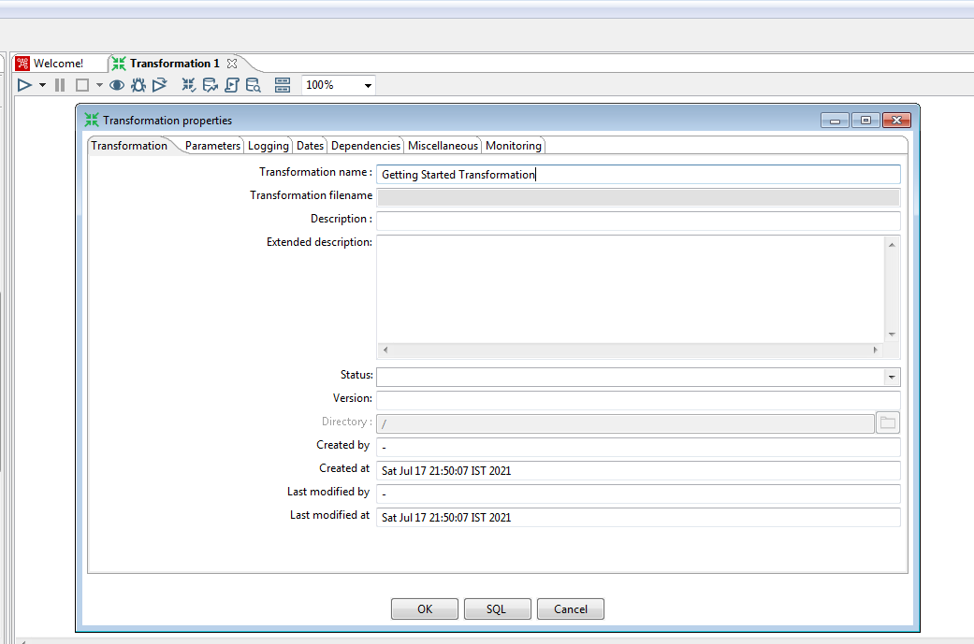

1. To save the transformation, select File Save. This is the first time you are saving transformation so you will be prompted for a file location and name of your choice. You will also see that .ktr is the usual file extension for transformations.

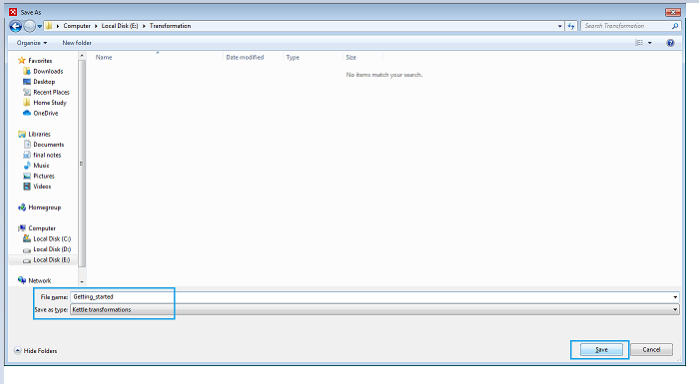

**Questions**

1. What is the extension for saving the transformations?

a.ktr b. kjb c. kmr d. tr

1. Which command is used to run a job in windows platform?

a. sh b.bat c.cmd d.notepad

3. What are the Steps of ETL Process?

a. define the source b. define the target c. create the mapping. d. All the above

**Subject Name :** Advanced Database Management System Lab

**Module No: 5**

**Experiment no.1**

**Aim :** Introduction to R.

**Objective:** To learn basics of R Programming. How to download and install R.

**Theory:**

## What is R Programming

R is an **interpreted computer programming language** developed by Ross Ihaka and Robert Gentleman in 1993. It is a software environment used to analyze statistical **information, graphical representation** and **reporting**.

In the current era, R is one of the most important tools used by researchers, data analyst, statisticians, and marketers for retrieving, cleaning, analyzing, visualizing, and presenting data. R allows integration with the procedures written in the C, C++, .Net, Python, and FORTRAN languages to improve efficiency.

# **Installation of R**

**R programming** is a very popular language and to work on it we must install two things, i.e., R and RStudio.

R and RStudio works together to create a project on R. Installing R to the local computer is easy. First, we must know which operating system we are using so that we can download the setup accordingly. The official site [https://cloud.r-project.org](https://cloud.r-project.org/) provides binary files for major operating systems including Windows, Linux, and Mac OS. In some Linux distributions, R is installed by default, which we can verify from the console by entering R.

### **R Installation in Windows**

Steps used to install the R in Windows are as follows:

**Step 1:**

First, we have to download the R setup from <https://cloud.r-project.org/bin/windows/base/>.

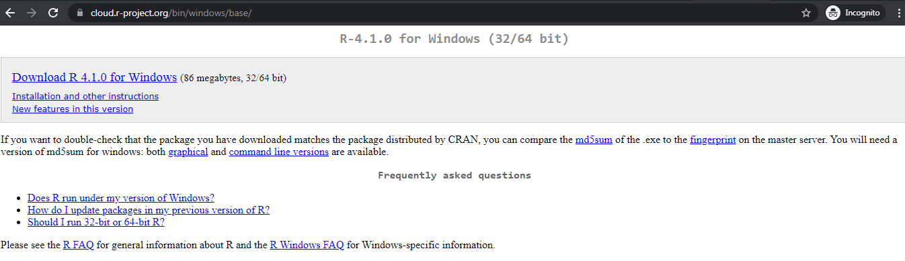

**Step 2:**

When we click on **Download R- 4.1.0 for windows**, our downloading will start. Once the downloading is finished, we have to run the setup of R as follows:

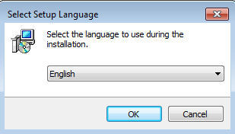

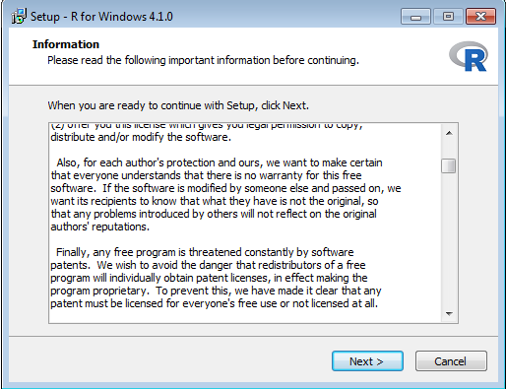

1) Select the path where we want to download the R and click **Next.**

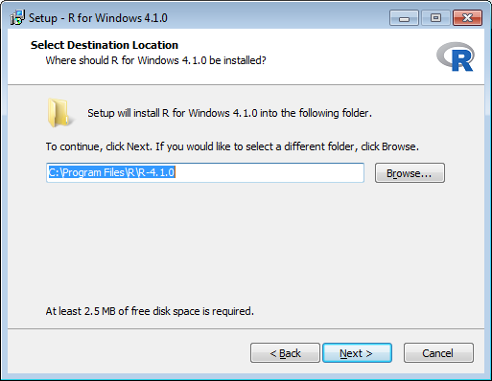

2) Select all components which we want to install, and then click **Next.**

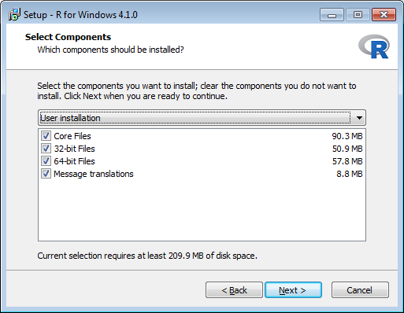

3) Now, we have to select either (customized startup) or (accept the default), and then click **Next**.

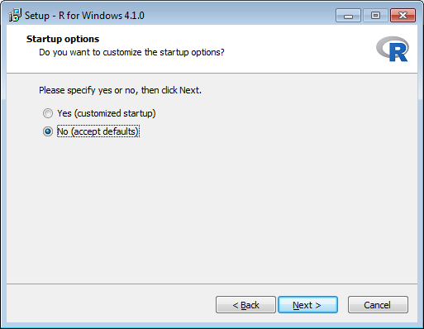

4) Now **Select Start Menu Folder** window will appear, click **Next**

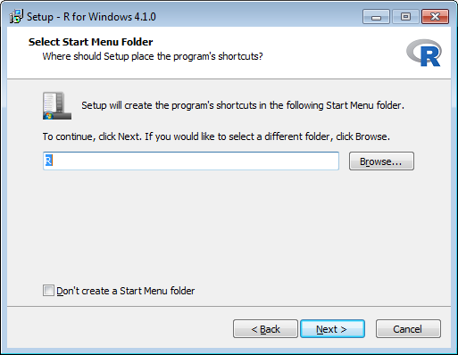

Click **Next**

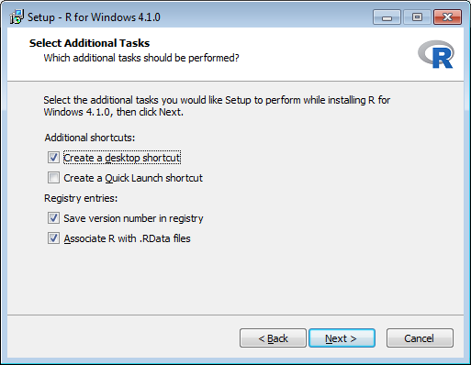

5) When we proceed to **Next**, installation of R will get started:

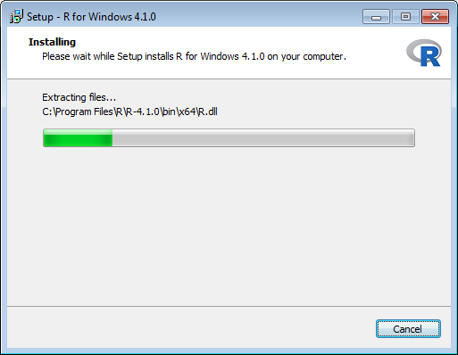

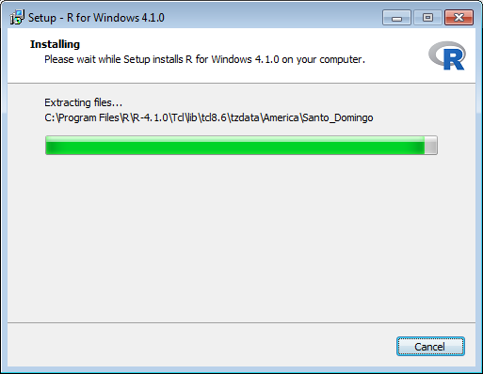

6) Finally, we will click on **Finish**.

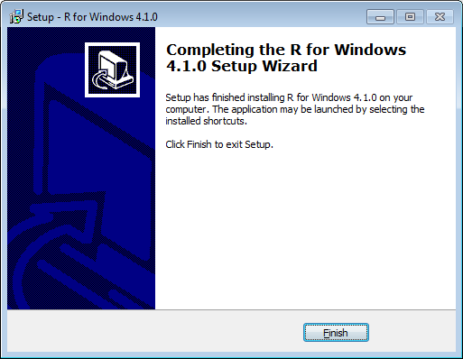

R has been successfully installed.

# **RStudio IDE**

RStudio is an integrated development environment which allows us to interact with R more readily. RStudio considered more user-friendly. This IDE has various drop-down menus, Windows with multiple tabs, and so many customization processes.

First time when we open RStudio, we will see three Windows. The fourth Window will be hidden by default. We can open this hidden Window by clicking the **File** drop-down menu, then **New File** and then **R Script**.

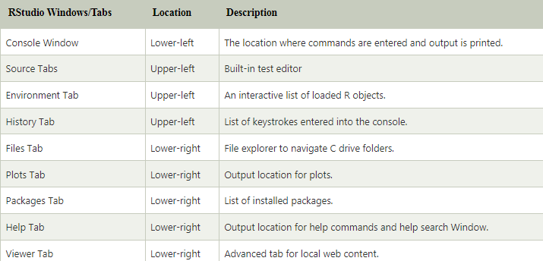

## Installation of RStudio

**RStudio Desktop version** is available for both Windows and Linux. The open-source RStudio Desktop installation is very simple to install on both operating systems.

**Installation on Windows/Linux**

The process of installing RStudio in both the OS Windows/Linux is same. Steps to install RStudio in Windows/Linux are as follows:

**Step 1:**

Visit the RStudio’s official website and click on **Download.**

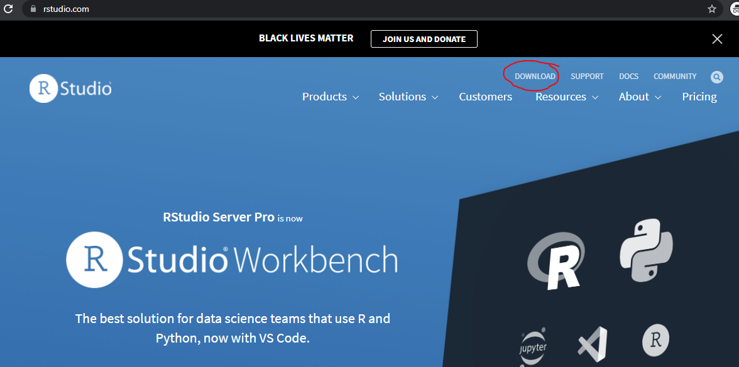

**Step 2:**

In the next step, we will select the RStudio desktop for open-source license.

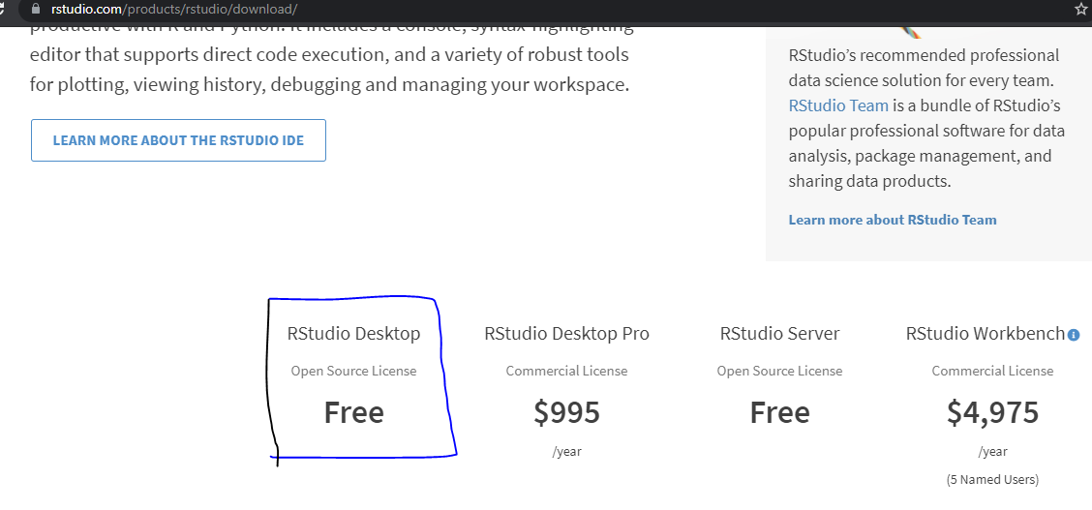

**Step 3:**

Now, Click on **Download RStudio for Windows**.

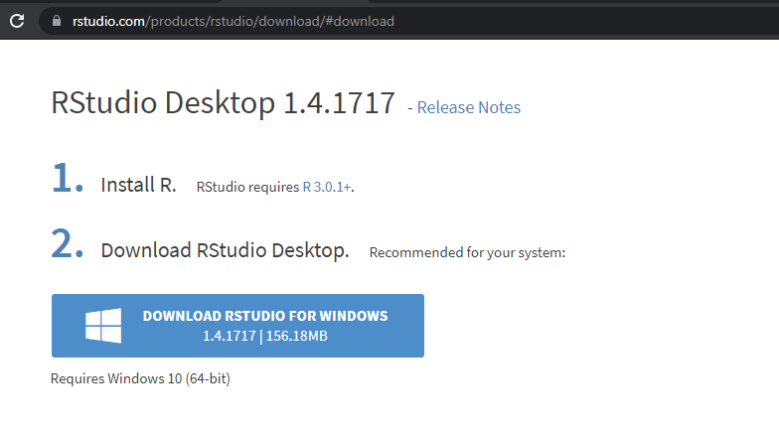

Downloading of RStudio setup will start.

**Step 4:**

Double click on downloaded (RStudio setup) file, it will open **Welcome to RStudio Setup window**. Click **Next.**

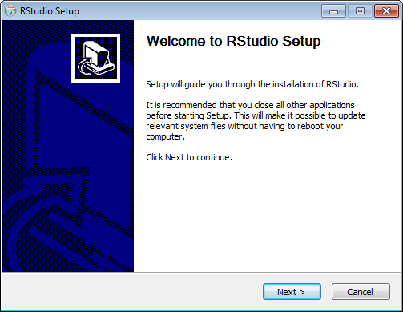

1) Click **Next**.

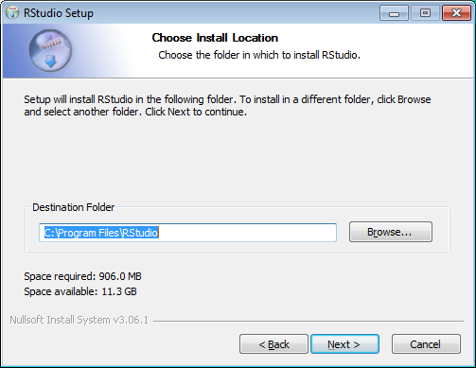

2) Click on **Install**.

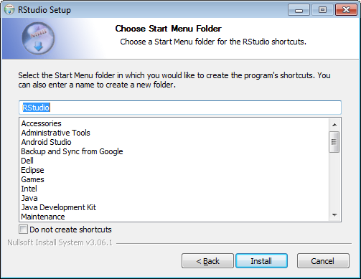

3) Now, Installation will start.

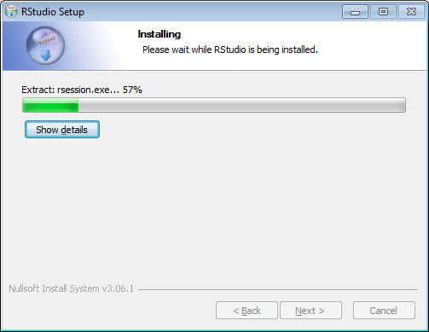

4) Click on **Finish**.

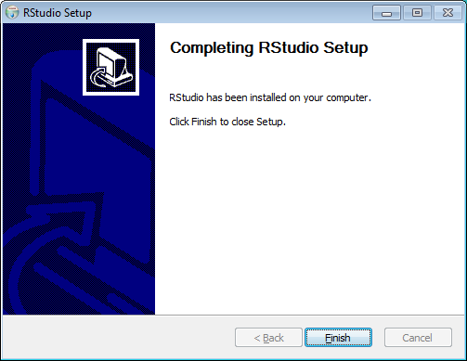

5) RStudio is ready to work.

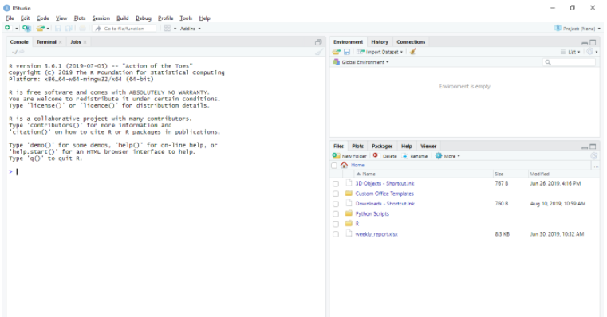

**Questions**

1. Who developed R?

a). Ross Ihaka b). Robert Gentleman c). Dennis Ritchie d). Both A and B

1. R allows integration with the procedures written in the?

a). C b). Ruby c). Java d). All of the above

1. Which of the following is used for executing R programs?

a). Google Chrome b). Microsoft word c) Command prompt d) R Studio

1. _______ is a software environment used to analyze statistical **information, graphical representation** and **reporting.**

a) Notepad b) C c) Firefox d) R

**Subject Name :** Advanced Database Management System Lab

**Module No: 5**

**Experiment no.2**

**Aim:** Data types in R Programming.

**Objective:** To understand different data types used in R programming. We will also learn how to use R console to execute programs.

**Theory:**

In programming languages, we need to use various variables to store information. Variables are reserved memory locations to store values. It means that when you create a variable you reserve some space in memory.

Each variable in R has an associated data type. Each data type requires different amounts of memory and has some specific operations which can be performed over it.

The following table shows the data type and the values that each data type can take.

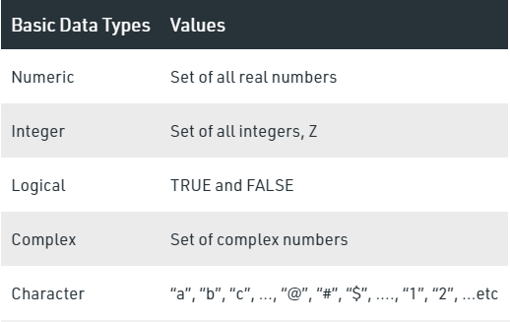

* **Numeric Datatype**

Decimal values are called numeric in R. It is the default data type for numbers in R. If you assign a decimal value to a variable x as follows, x will be of numeric type.

| **# R Program to illustrate Numeric data type**  # Assign a decimal value to variable x  x = 5.6  # print the class name of variable x  print(class(x)) |
| --- |
| # print the type of variable x  print(typeof(x)) |
| **Output:**  [1] "numeric"  [1] "double" |

Steps to execute above program in RStudio:

1. Open RStudio.

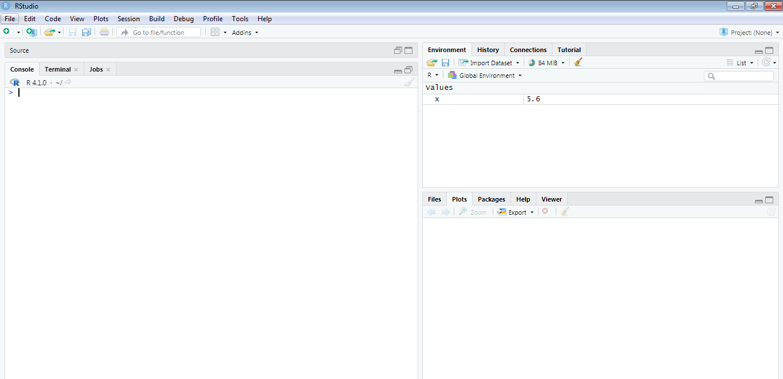

1. Type your program in console and press enter to see the output.

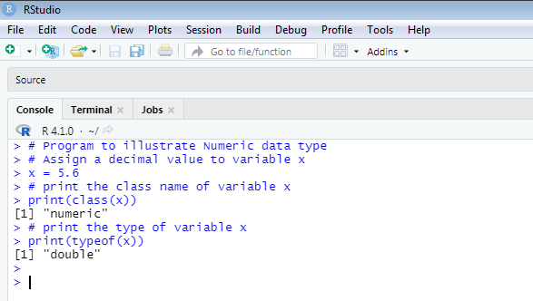

Even if an integer is assigned to a variable y, it is still being saved as a numeric value.

# **R program to illustrate Numeric data type**

# Assign an integer value to variable y

y = 5

# print the class name of variable y

print(class(y))

# print the type of variable y

print(typeof(y))

**Output:**

[1] "numeric"

[1] "double"

When R stores a number in a variable, it converts the number into a “double” value or a decimal type with at least two decimal places. This means that a value “5” here, is stored as 5.00 with a type of double and a class of numeric.

And also variable y is not an integer here. It can be confirmed by using **is.integer()** function.

**# R program to illustrate Numeric data type**

# Assign an integer value to variable y

y = 5

# is variable y an integer?

print(is.integer(x))

**Output:**

[1] FALSE

#### **Integer Datatype**

R supports integer data types which are the set of all integers. You can create as well as convert a value into an integer type by using the **as.integer()** function. You can also use the capital letter ‘L’ as a suffix to denote that a particular value is of the integer data type.

**# R program to illustrate integer data type**

# Create an integer variable

x = as.integer(5)

# print the class name of variable x

print(class(x))

# print the type of variable x

print(typeof(x))

# Declare an integer by appending ‘L’ as suffix.

y = 5L

# print the class name of y

print(class(y))

# print the type of y

print(typeof(y))

Output:

[1] "integer"

[1] "integer"

[1] "integer"

[1] "integer"

* **Logical Datatype**

R has logical data types which take only two values either a true or false.

**# R program to illustrate logical data type**

# Two variables

x = 4

y = 3

# Comparing two values

z = x > y

# print the logical value

print(z)

# print the class name of z

print(class(z))

# print the type of z

print(typeof(z))

**Output:**

[1] TRUE

[1] "logical"

[1] "logical"

* **Complex Datatype**

R supports complex data types which are set of all the complex numbers. The complex data type is used to store numbers with an imaginary part.

**# R program to illustrate complex data type**

# Assign a complex value to variable x

x = 4 + 3i

# print the class name of variable x

print(class(x))

# print the type of variable x

print(typeof(x))

**Output:**

[1] "complex"

[1] "complex"

* **Character Datatype**

R language supports character data types where you have all the alphabets and special characters. It stores character values or strings. Strings in R can contain alphabets, numbers, and symbols. The easiest way to show that a value is of character type in R is to enclose the value inside single or double inverted commas.

**# R program to illustrate character data type**

# Assign a character value to char

char = "MumbaiUniversity"

# print the class name of char

print(class(char))

# print the type of char

print(typeof(char))

**Output:**

[1] "character"

[1] "character"

**Questions:**

1. What will be output for the following code?

**>a <- TRUE**

**>print(class(a))**

a) logical b) Numeric c) Integer d) Complex

1. If you explicitly want an integer, you need to specify the _____ suffix.

a) D b) R c) L d) K

3. What will be the output of the following R code?

**> x <- 6**

**> class(x)**

a) “integer” b) “numeric” c) “real” d) “imaginary”

4. What will be output for the following code?

**>v <- "MumbaiUniversity"**

**>print(class(v))**

a). logical b) Numeric c) Integer d) Character

5. What will be output for the following code?

**> sqrt(-17)**

a) -4.02 b) 4.02 c) 3.67 d) NAN

6. Decimal values are referred as ________ data types in R.

a) Numeric b) Character c). Integer d) Lists

**Subject Name:** Advanced Database Management System Lab

**Module No: 5**

**Experiment no.3**

**Aim:** Reading and Writing data to and from R.

**Objective:** To learn how to read data in R and write (export) data to files in R.

**Theory:**

#### **Functions for Reading Data into R:**

1. **read.table()** and  **read.csv()** : functions used for reading tabular data into R.
2. **readLines()** : for reading lines from a text file.
3. **source()** : function for reading in R code files from a another R program.
4. **dget() :** function for reading in R code files.
5. **load() :**  function is used for reading in saved workspaces.

#### **Functions for Writing Data to Files:**

1. **write.table()** : for writing tabular data to text files (i.e. CSV).
2. **writeLines() :** function is useful for writing character data line-by-line to a file or connection.
3. **dump()** : function for dumping a textual representation of multiple R objects.
4. **dput()** : function is used for outputting a textual representation of an R object.
5. **save()** : for saving an arbitrary number of R objects in binary format  to a file.

**Reading data files with read.table()**

The read.table() function is one of the most common used functions for reading data into R. It has following arguments.

The function **read.table()** can be used to read the data frame.

We have kept record.txt and record.csv files under datasets folder inside E: drive.

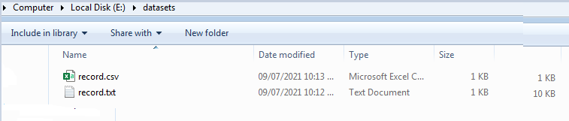

> record_data <- read.table("E:/datasets/record.txt")

>head(record_data) #returns first n rows of the data

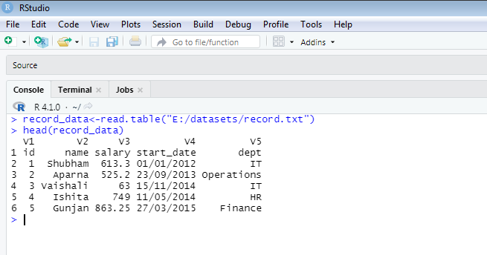

Similarly, **read.csv()** function can be used to read data from csv files.

> record_data <- read.csv("E:/datasets/record.csv")

>head(record_data) #returns first n rows of the data

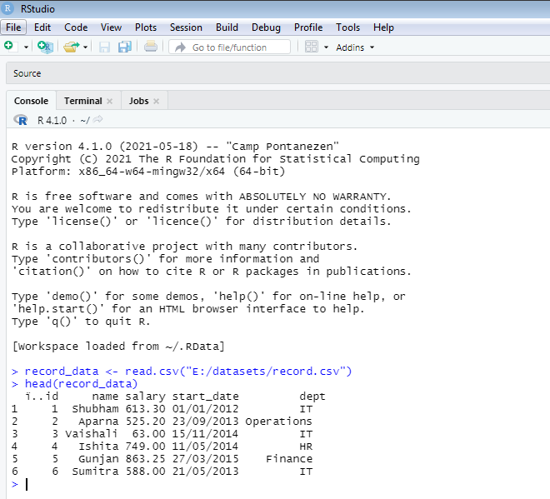

* **Writing Data to a File**

After working with a dataset, we might like to save it for future use. Before we do this, let's first set up a working directory so we know where we can find all our data sets and files later.

## Setting up a Directory

From RStudio, use the menu to change your working directory under **Session > Set Working Directory > Choose Directory**.

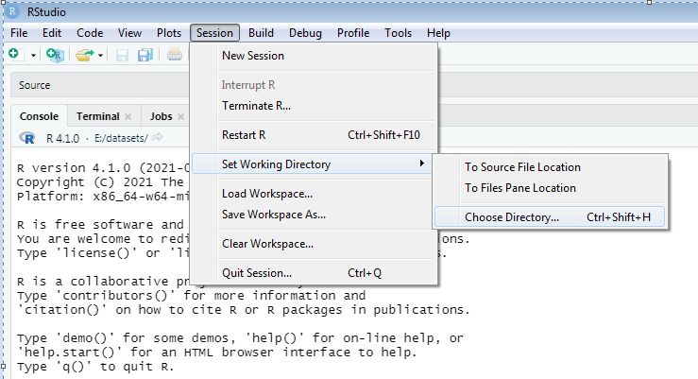

Click Open.

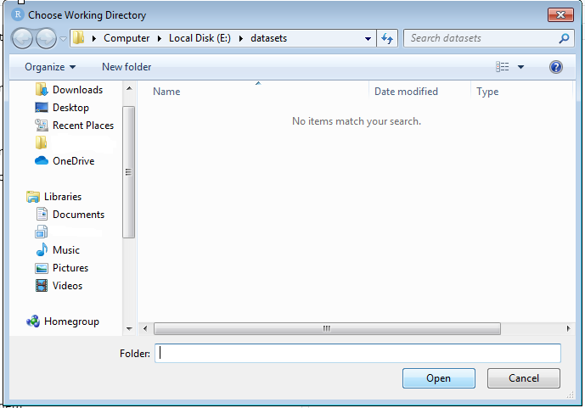

Alternatively, you can use the setwd() function to assign working directory.

> setwd("E:/datasets")

To check your current working directory, type

> getwd()

In R, we can write data easily to a file, using the write.table() command.

**x<-data.frame(name ="Ishita", department = "IT")**

**write.table(x, file ="data.csv", sep = ",")**

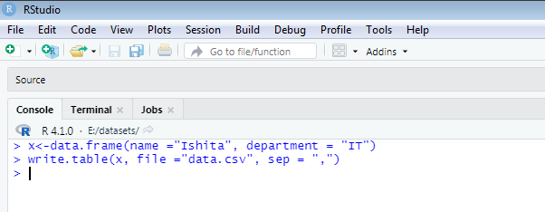

Following are few important arguments used in write.table() function.

* **x**, the object to be written, typically a data frame.
* **file**, the name of the file which the data are to be written to.
* **sep**, the field separator string.

Now, let's check whether R created the file data.csv under E:/datasets folder or not.

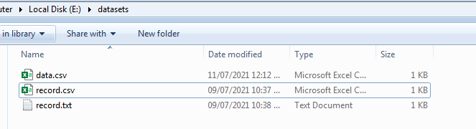

By going to this location E:/datasets, you should see a data.csv file.

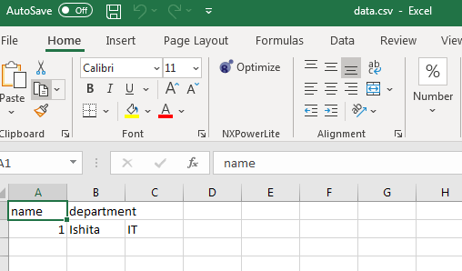

**y<-data.frame(name ="Ankit", department = "HR")**

**write.table(y, "E:/datasets/mydata.txt", sep = "\t")**



Now, let's check whether R created the file mydata.txt under E:/datasets folder or not.

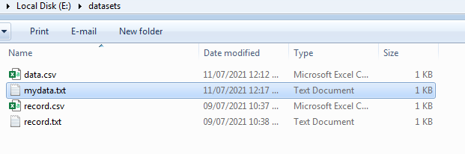

By going to this location E:/datasets, you should see a mydata.txt file.

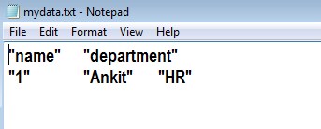

**z <- data.frame(a = 10, b = 40, c = pi)**

**write.csv(z, file = "sample.csv")**

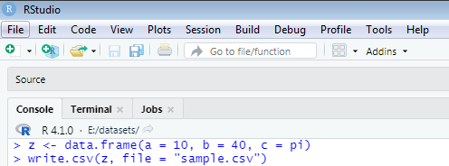

Now, let's check whether R created the file sample.csv under E:/datasets folder or not.

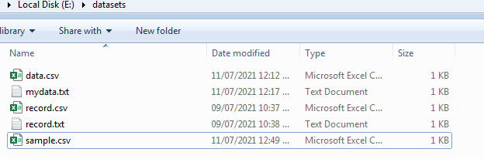

By going to this location E:/datasets, you should see a sample.csv file.

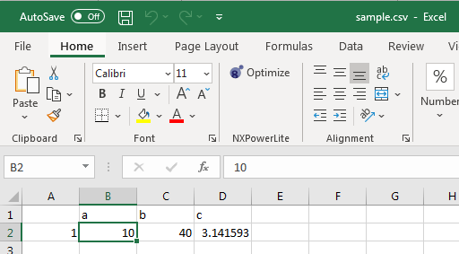

**Questions:**

1. Which of the following is used for reading tabular data?

a) read.csv b) dget c) readLines d) writeline

1. Which of the following function is identical to read .table?

a) read.csv b) read.data c) read.tab d) read.del

1. ________ is used for outputting a textual representation of an R object.

a) dput b) dump c) dget d) dset

1. Which of the following function is identical to read.table?

a) read.csv b) read.data c) read.tab d) read.del

**Subject Name:** Advanced Database Management System Lab

**Module No: 5**

**Experiment no.4**

**Aim:** Packages in R programming.

### **Objective:** To learn R packages**.** How to install a new Package in R?

**Theory:**

# **R Packages**

R packages are the collection of R functions, sample data and compile codes. In the R environment, these packages are stored under a directory called "**library**." By default, during installation R installs a set of packages. We can add packages later also when they are needed for some specific purpose.

When we start the R console, only the default packages are available by default. Other packages which are already installed will be loaded explicitly to be used by the R program.

All the packages available in R language are listed at

**https://cran.r-project.org/web/packages/available_packages_by_name.html**

List of commands that can be used to check, verify, and use the R packages are as follows.

* **Check Available R Packages**
* Get library locations containing R packages.

.libPaths()

When we execute the above code, it will produce the following result.

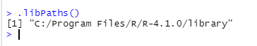

* **Get the list of all the packages installed**

library()

When we execute the above code, it will produce the following result.

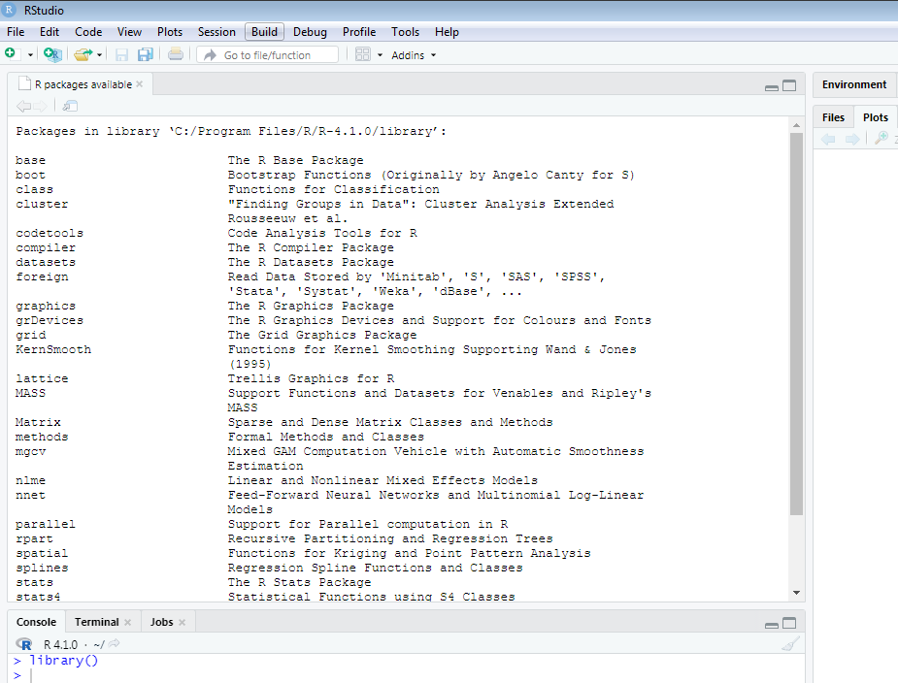

R provides **search() function** to get all packages currently loaded in the R environment.

**search()**

When we execute the above code, it will produce the following result, which may vary depending on the local settings of our PCs and laptops:

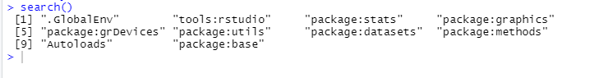

* **Install a New Package**

In R, there are two ways to add new packages. One is install it directly from the CRAN directory and another is download the package to your local system and install it manually.

* Install directly from CRAN

The following command gets the packages directly from CRAN webpage and installs the package in the R environment.

install.packages("Package Name")

**install.packages("XML") # Install the package named "XML".**

outpu 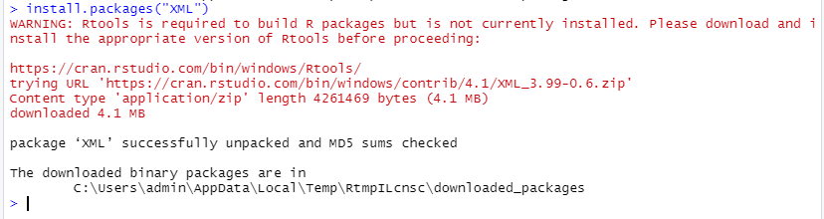

**Install package manually**

To install a package manually, we first have to download it from <https://cran.r-project.org/web/packages/available_packages_by_name.html>. Save the package as a .zip file in a suitable location in the local system.

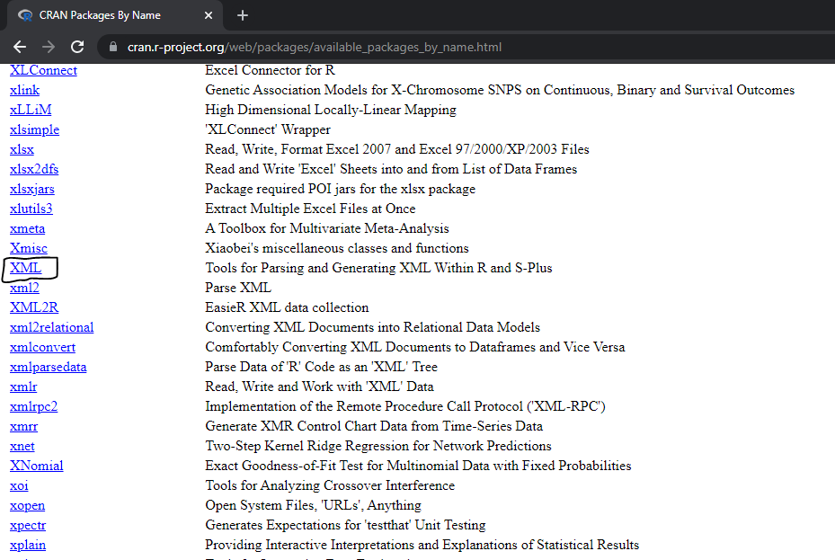

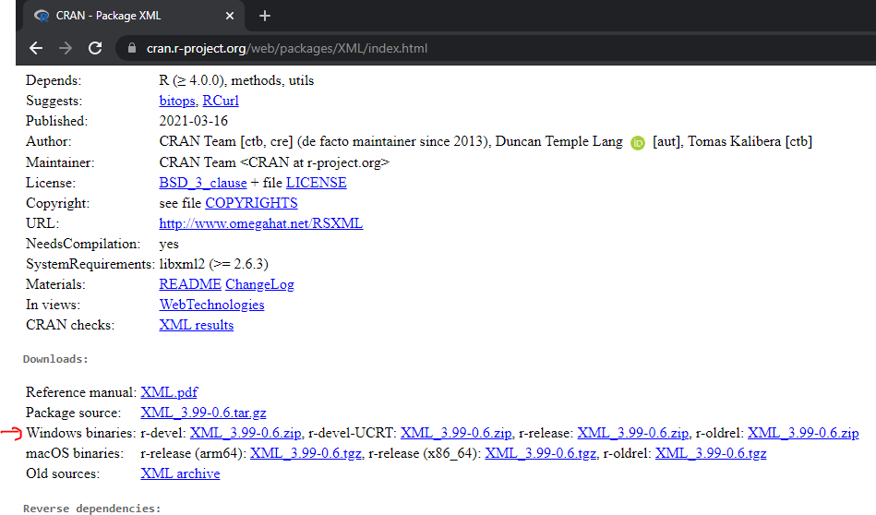

Once the downloading has finished, we will use the following command:

install.packages(file_name_with_path, repos = NULL, type = "source")

**# Install the package named "XML"**

**install.packages("E:/XML_3.99-0.6.zip", repos = NULL, type = "source")**

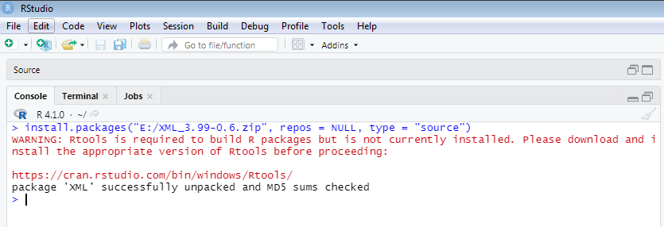

### **Load Package to Library**

We cannot use the package in our code until its not loaded into the current R environment. We also need to load a package which is already installed but not available in the current environment.

A package is loaded using the following command –

library("package Name", lib.loc = "path to library")

**# Load the package named "XML"**

**install.packages("E:/XML_3.99-0.6.zip", repos = NULL, type = "source")**

# **List of R packages**

R is the language of data science which includes a vast repository of packages. CRAN has 10,000 packages, making it an ocean of superlative statistical work. Most popular packages which are used in R as follows:

### **1) tidyr**

The word tidyr comes from the word tidy, which means **clear**. **tidyr** package is used to make the data' tidy'.

### **2) ggplot2**

R provides the **ggplot** package for creating graphics declaratively. This package is famous for its elegant and quality graphs which sets it apart from other visualization packages.

### **3) ggraph**

R provides an extension of ggplot known as **ggraph**. The limitation of **ggplot** is the dependency on tabular data is taken away in ggraph.

### **4) dplyr**

R provides the **dplyr** library for performing data wrangling and data analysis. This library facilitates several functions for the data frame in R.

### **5) tidyquant**

The tidyquant is a financial package which is used for carrying out quantitative financial analysis. This package adds to the **tidyverse** universe as a financial package which is used for importing, analyzing and visualizing the data.

### **6) dygraphs**

The dygraphs package provides an interface to the main JavaScript library which we can use for charting. This package is essentially used for plotting time-series data in R.

### **7) leaflet**

For creating interactive visualization, R provides the **leaflet** package. This package is an open-source JavaScript library. The world's popular websites like the New York Times, Github and Flicker, etc. are using leaflet. The leaflet package makes it easier to interact with these sites.

### **8) ggmap**

### This is a mapping package that is used for delineating spatial visualizations. It also consists of various tools for geolocating and routing.

### **9) glue**

R provides the **glue** package to perform the operations of data wrangling. This package is used for evaluating R expressions which are present within the string.

### **10) shiny**

R allows us to develop interactive and aesthetically pleasing web apps by providing a **shiny** package. This package provides various extensions with HTML widgets, CSS, and JavaScript.

### **1) plotly**

The plotly package provides online interactive and quality graphs. This package extends upon the JavaScript library **-plotly.js**.

### **12) dichromat**

The R dichromat package is used to remove Red-Green or Blue-Green contrasts from the colors.

### **13) digest**

The digest package is used for the creation of cryptographic hash objects of R functions.

### **14) caret**

R allows us to perform classification and regression tasks by providing the caret package. **CaretEnsemble** is a feature of caret which is used for the combination of different models.

### **15) e1071**

The **e1071** library provides useful functions essential for data analysis like Naive Bayes, Fourier Transforms, SVMs, Clustering, and other miscellaneous functions.

### **16) sentimentr**

The sentiment package provides functions for carrying out sentiment analysis. It is used to calculate text polarity at the sentence level and to perform aggregation by rows or grouping variable.

**Questions:**

1. Which of the following syntax is used to install forecast package in R?
2. install.pack("forecast")
3. installing.packages("cast")
4. install.packages("forecast")
5. install.pack["forecast"]
6. ______ is used to view all packages installed in R.

a) library()

b) search()

c) .libPaths()

d) stringr()

1. ______ function is used to get library location in R.

a) library()

b) search()

c) .libPaths()

d) stringr()

1. ________ function is used to view packages currently loaded.

a) library()

b) search()

c) .libPaths()

d) stringr()

**Subject Name :** Advanced Database Management System Lab

**Module No: 6**

**Experiment no.1**

**Aim :** Data preprocessing in R.

**Objective:** What is data preprocessing? Different steps involved in data preprocessing.

**Theory:**

* **Data Preprocessing**

Data preprocessing is a process of preparing the raw data to make it suitable for a machine learning model. It is the first and crucial step while making any machine learning model.

When creating a machine learning model, it is not a case that we come across the clean and formatted data always. It is mandatory to clean the data and put it in a formatted way before using it for any model. So, for this we use data preprocessing.

## Why do we need Data Preprocessing?

A real-world data generally contains noises, missing values, and maybe in an unusable format which cannot be directly used for machine learning models. Data preprocessing is used for cleaning the data and making it suitable for a machine learning model which also increases the accuracy and efficiency of a machine learning model.

### **Data Preprocessing in R**

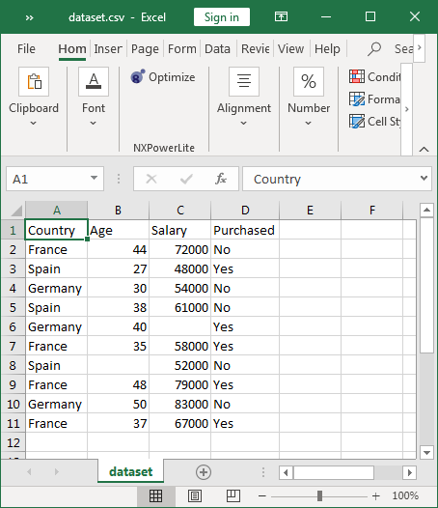

dataset.csv file

#### **Importing the Dataset**

Here, first we will change the working directory to E:/datasets (where dataset.csv is stored)

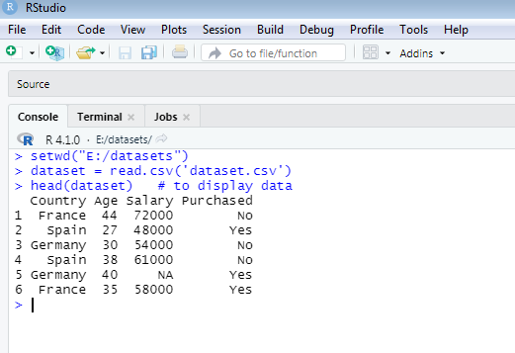

To display all 7 rows from csv file

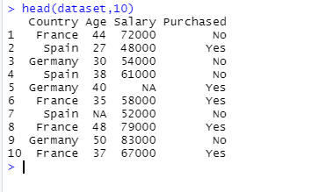

This dataset consists of four features. The dependent factor is the **‘Purchased’** column.

If the above dataset is to be used for machine learning model, the idea will be to predict if an item got purchased or not depending on the Country, Age and Salary of a person. The highlighted cells with value ‘NA’ denote missing values in the dataset.

* **Dealing with Missing Values**

dataset$Age = ifelse(is.na(dataset$Age),ave(dataset$Age, FUN = function(x) mean(x, na.rm = 'TRUE')),dataset$Age)

dataset$Salary = ifelse(is.na(dataset$Salary), ave(dataset$Salary, FUN = function(x) mean(x, na.rm = 'TRUE')), dataset$Salary)

The above code checks for missing values in the Age and Salary columns and update the missing cells with the column-wise average.

* **dataset$column_header:**

Selects the column in the dataset specified after $ (Age and Salary).

* **is.na(dataset$column_header):**

This method returns true for all the cells in the specified column with no values.

* **ave(dataset$column_header, FUN = function(x) mean(x, na.rm = ‘TRUE’)):**

This method calculates the average of the column passed as argument.

**Output:**

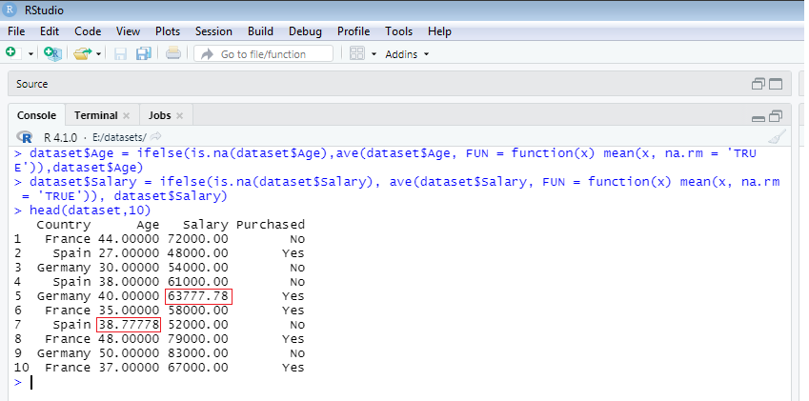

Since we don’t want decimal places for Age, we will round it up using the following code.

dataset$Age = as.numeric(format(round(dataset$Age, 0)))

The argument 0 in the round function means no decimal places.

After executing the above code block , the dataset would look like what’s shown below :

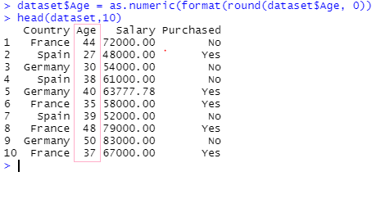

#### **Dealing with Categorical Data**

Categorical variables represent types of data which may be divided into groups. Examples of categorical variables are race, sex, age group, educational level etc.

In our dataset, we have categorical features ‘Purchased’. In R we can use the factor method to convert texts into numerical codes.

dataset$Purchased = factor(dataset$Purchased, levels = c('No','Yes'),  labels = c(0,1))

* **factor(dataset$olumn_header, levels = c(), labels = c()) :**

the factor method converts the categorical features in the specified column to factors or numerical codes.

* **levels:**

The categories in the column passed as a vector. Example c(‘No’,’Yes’)

* **labels:**

The numerical codes for the specified categories in the same order. Example c(0,1))

**Output:**

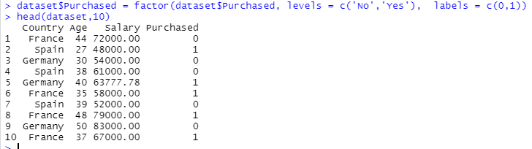

**Questions:**

1. Incorrect or invalid data is known as _________.

a. Missing data b. Outlier c. Changing data d. Noisy data

2. What will be the output of the following R code?

**> x <- c(2, 6, NaN, NA, 4)**

**> is.na(x)**

a) FALSE FALSE TRUE TRUE FALSE

b) FALSE TRUE TRUE TRUE FALSE

c) TRUE FALSE TRUE TRUE FALSE

d) TRUE FALSE TRUE FALSE FALSE

3. ___________is used for cleaning the data and making it suitable for a machine learning model.

a. Data preprocessing

b. Saving the data

c. Data Repairing

d. Data removing

**Subject Name Advanced DBMS**

**Module No 07**

**Experiment No. 01**

**Aim:** To implement and analyse linear regression

**Objective**:- To understand linear regression which is a statistical model to study the relationship that could exist between two variable quantities : one of the variables is called independent variable(x) and the other is known as dependent variable(y).

**Theory**:

LINEAR REGRESSION

The independent and dependent variables are assumed to have a linear relationship in linear regression. This implies that a line can be drawn between the two.

The relation between two quantitative variables is estimated using simple linear regression. When you need to know the following, you can apply simple linear regression:

1)What is the extent of the association between the two variables?

2) The value of the dependent variable at a given value of the independent variable.

**Program:**

In this program, ages and heights of people are recorded in an excel file “ageandheight.xls” and the relationship between ages (independent variable) and heights(dependent variable) is studied.

This relationship between heights and ages can be expressed as a linear equation:

Heights = m*ages + c.

M is the slope of the line and c is the intercept.

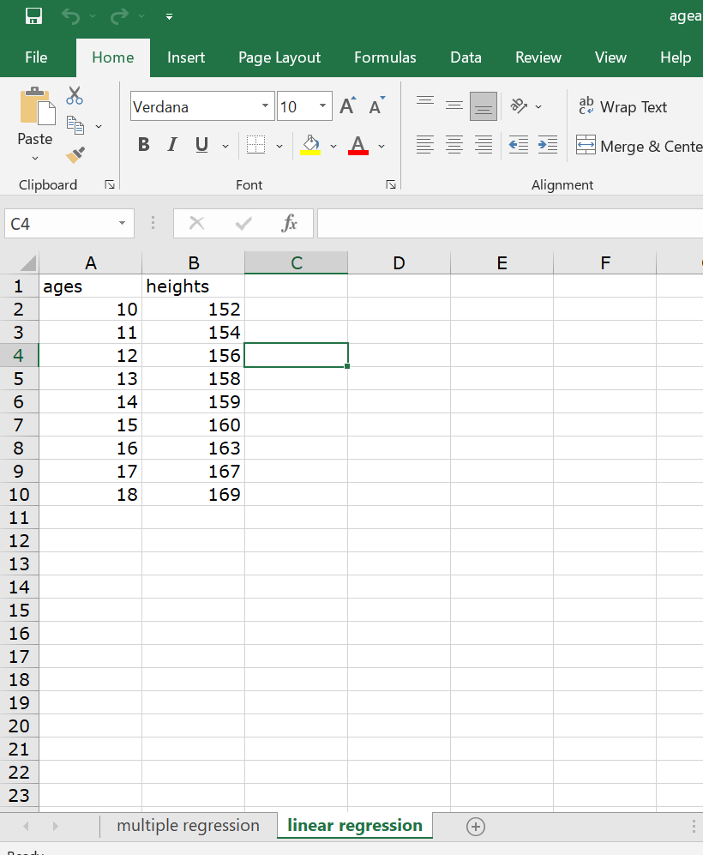

(ageandheight.xls file )

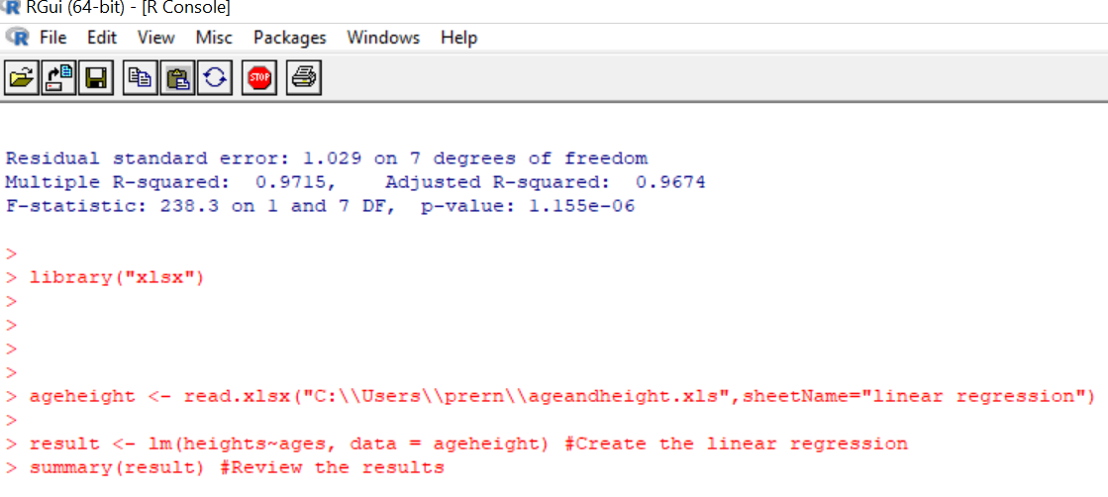

**Output :**

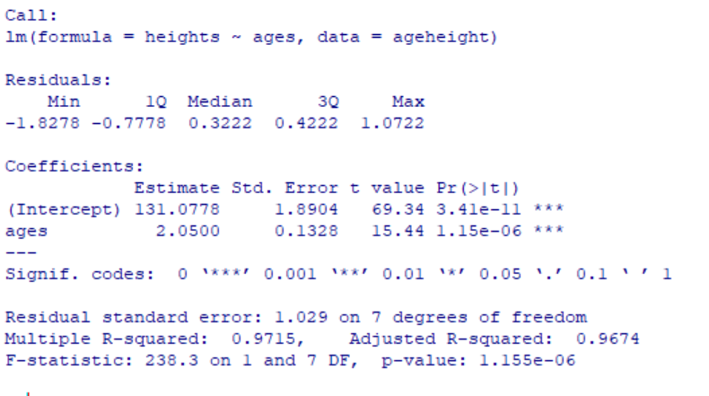

Residuals: The intention is for the sum of the residuals to be close to zero or as low as possible. Most cases will not follow a completely straight line in real life, hence residuals are always to be expected.

Coefficients: The values of the intercept (“c” value) and the slope (“m” value) for the age can be seen These “c” and “m” values are used to draw a line between all the points of the data.

So in this case, if there is a person whose age is 18, then the height can be calculated as (18*2.0500 + 131.0778)

The p-value for the age is 0.000001155. The smaller the value the better is ‘ages’ a good determinant of ‘heights’.

R² value is almost 1 for models that fit well and in case of models that poorly fit the data have R² value near about 0. In this output R squared value is 0.9715 which explains almost 97% of the variability.

**Questionnaire**

1. The number of variables used in linear regression is

a) 2 b) 3 c)4 d)0

2. Linear regression is a ______ model.

a) statistical b) non-statistical

b) c) cannot say d) both

3. The smaller the p value for independent variable the better it is a predictor for dependent variable’s value

a) True b) False c) Cannot Say d) All of the above

4. Generally, a ______ R squared value suggests a better fitting model.

a) greater b) smaller c) both d)None

5. In linear regression, two variables form _____ relationship

a)linear b)non-linear c)quadratic d) polynomial

6. If the sum of the residuals is zero, then it is the ideal scenario.

a) True b) False c) Cannot Say

**Experiment No. 02**

**Aim:** To implement and analyse multiple linear regression

**Objective:-** To understand multiple linear regression which is a statistical model to study the relationship that could exist between variable quantities : here there are multiple independent variables(x1, x2, x3…..) to predict a dependent variable(y).

**Theory:**

MULTIPLE LINEAR REGRESSION

The independent and dependent variables are assumed to have a linear relationship in linear regression. This implies that a line can be drawn using them.

The relation between three or more quantitative variables is estimated using multiple linear regression. Analysts can use multiple linear regression to determine the model's variance and the relative contribution of each independent variable.

Multiple linear regression is used when one wants to know:

1. How strong the relationship is between two or more independent variables and one dependent variable (eg price of the houses and factors determining them like location,area etc)
2. The value of the dependent variable at a certain value of the independent variables (e.g. the expected price of a house at a particular value of location ,area etc ).

**Program:**

In this program, ages , number of brothers and heights of people are recorded in an excel file “ageandheight.xls” and the relationship between heights (dependent variable) and two independent variables – ages and number of brothers is studied.

This relationship between heights and ages, number of brothers can be expressed as a linear equation:

Heights = (m1*ages) + (m2* no_of_brothers) + c.

M1 and m2 are the co-efficients and c is the intercept.

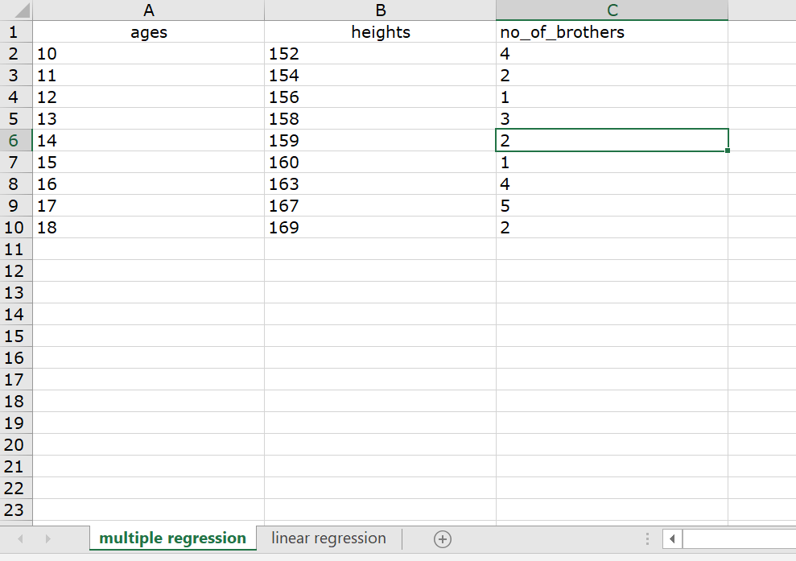

(ageandheight.xls file )

Program:

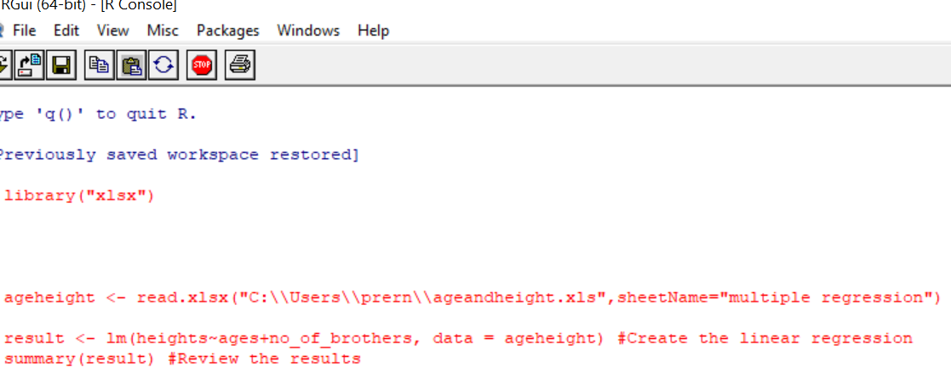

**Output :**

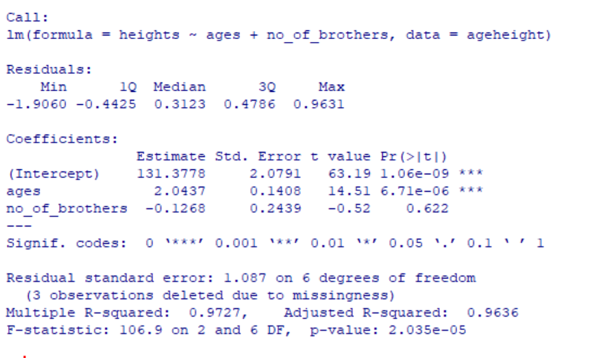

Residuals: The intention is for the sum of the residuals to be close to zero or as low as possible. Most cases will not follow a completely straight line in real life, hence residuals are always to be expected.

Coefficients: The values of the intercept (“c” value) and the “m1” value for the ages and “m2” value for the number of brothers can be seen. These “c” and “m1,m2” values are used to draw a line between all the points of the data.

So in this case, if there is a person whose age is 18 and no of brothers is 2, then the height can be calculated as (18*2.0437 + 2* -0.1268 + 131.3778)

The p-value for the age is 0.00000671. The smaller the value the better is ‘ages’ a good determinant of ‘heights’.

The p-value for the no_of _brothers is 0.622. It means there is a 62% chance that number of brothers is not a good determinant of ‘heights’

R² value is almost 1 for models that fit well and in case of models that poorly fit the data have R² value near about 0. In this output R squared value is 0.9727 which explains almost 97% of the variability.

**Questionnaire**

1. The number of independent variables used in multiple linear regression is

a) >=2 b) 1 c)2 d)0

2. Multiple Linear regression is an extension of ______ linear regression.

a) simple b) complex

b) c) cannot say d) both

3. The smaller the p value for independent variable the better it is a predictor for dependent variable’s value

a) True b) False c) Cannot Say d) All of the above

4. Generally, a ______ R squared value suggests a not so good fitting model.

a) greater b) smaller c) both d)None

5. In multiple linear regression, quantitative variables form _____ relationship

a)linear b)non-linear c)quadratic d) polynomial

6. If the sum of the residuals is not zero, then it is the ideal scenario.

a) True b) False c) Cannot Say

**Experiment No. 03**

**Aim:** To implement and analyse Classification model - logistic regression.

**Objective**:- To understand logistic regression which is a classification algorithm that predicts categorical value of the response variable given multiple predictor variables values.

**Theory:**

LOGISTIC REGRESSION

It is used to predict a binary result from a set of independent variables (Eg : 1 / 0, Yes / No, True / False,Male/Female). If the outcome variable is categorical, you may think of logistic regression as a particular instance of linear regression with the log of chances as the dependent variable. To put it another way, it forecasts the likelihood of something happening.

One may use logistic regression as an example of a classification approach to predict a qualitative response.

**Program:**

Mtcars is an inbuilt dataset in R. We have considered the attributes ‘hp’ i.e. gross horsepower of car engine and ‘gear’ i.e. number of forward gears in determining transmission mode i.e. 0 which means automatic and 1 which means manual. The variable “am” is categorical that is it can have only 2 values.

The glm() (generalised linear model ) function creates the regression model and summary() function generates the summary for analysis.

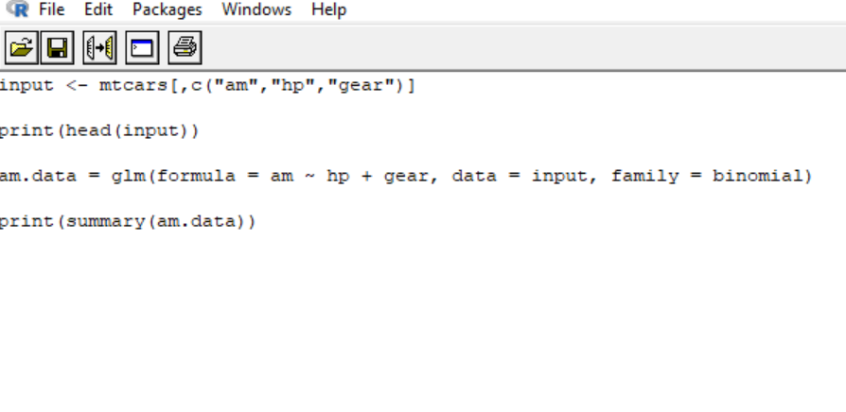

**Output:**

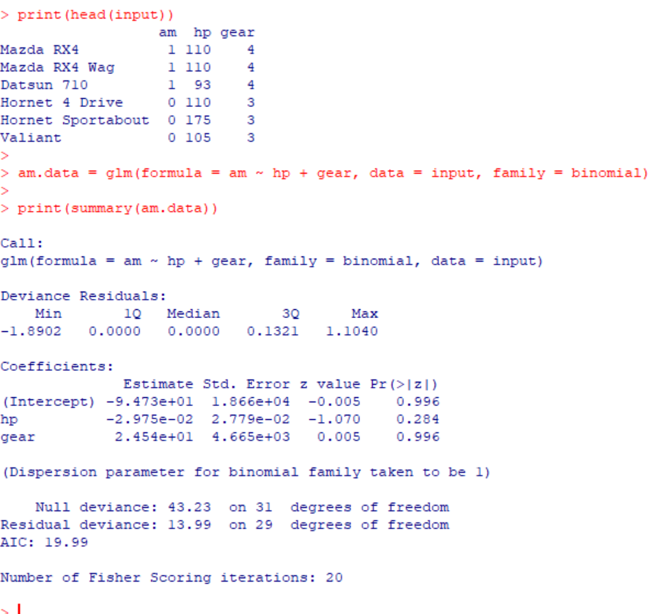

From the above observations, it is seen that both hp and gear values have p values more than 0.05. So it can be said that neither hp nor gear are significant in the logistic regression model.

Deviance is a metric of goodness of fit of a model. Larger numbers always mean it is a bad fit.

The number of Fisher Scoring iterations : It indicates the ideal number of iterations to fit the model. For example, beyond some number of iterations there is nothing to be practically gained.

**Questionnaire**

1. Logistic Regression is based on probability

a) True b) False c)Both d)None

2. Logistic Regression is useful in case of qualitative data

a) True b) False

b) c) cannot say d) both

3. Logistic Regression measures the probability of ____ response

a) Binary b) Tertiary c) Cannot Say d) All of the above

4. Logistic Regression algorithms are a part of class of_______ linear model.

a) generalized b) particular c) both d)None

5. Predicting a qualitative response from an observation is _______ of observation.

a)classification b)summarizing c)reducing the number d) None

6. Which one predicts probability?

a) Linear Regression b) Logistic Regression c) Cannot Say

**Experiment No. 04**

**Aim**: To implement one classification algorithm in Weka.

**Objective**:- To implement classification algorithm K-Nearest Neighbour using WEKA

**Theory:**

KNN Algorithm

The K-Nearest Neighbour method is based on the Supervised Learning approach and is one of the most basic Machine Learning algorithms.

The K-NN method assumes that the new case/data and existing cases are comparable and places the new case in the category that is most similar to the existing categories.

The K-NN method saves all available data and classifies a new data point based on its similarity to the existing data.

It is called as lazy method because when you give the training data, it conducts no training at all. At training time, it does nothing except store the whole data set and does not do any calculations.

**Algorithm:**

Step-1: Select K number of the neighbours

Step-2: Compute the Euclidean distance of those K number of neighbours

Step-3: Take the K nearest neighbours according to the computed Euclidean distance.

Step-4: Between these k neighbours, count the number of the data points in each category.

Step-5: Assign the new data to that category for which the number of the neighbours is the maximum value.

**Program:**

Steps :

1. Choose Explorer option

The following Window will pop up

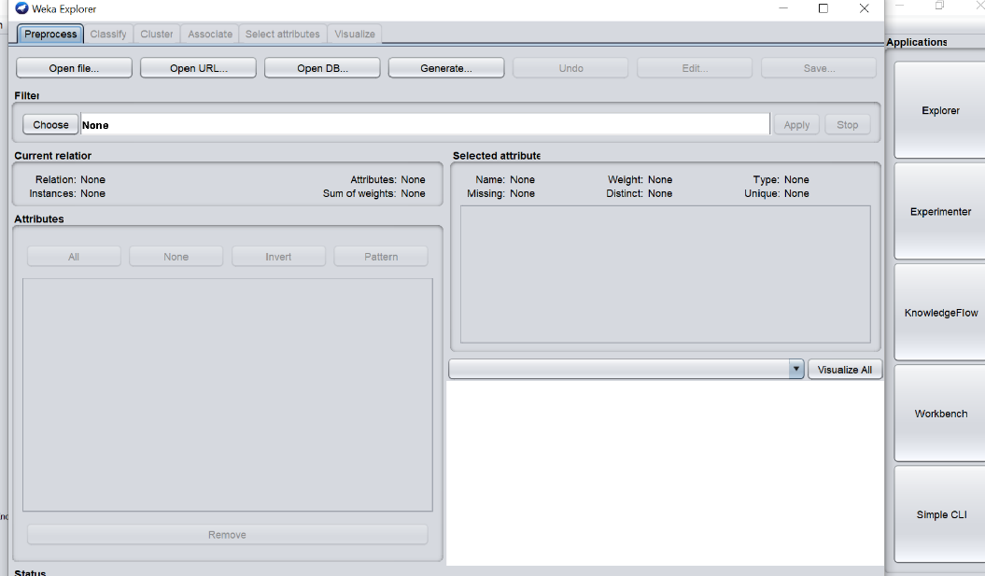

1. Select Open File
2. Select Drive name and choose Weka Folder
3. Select Data Folder

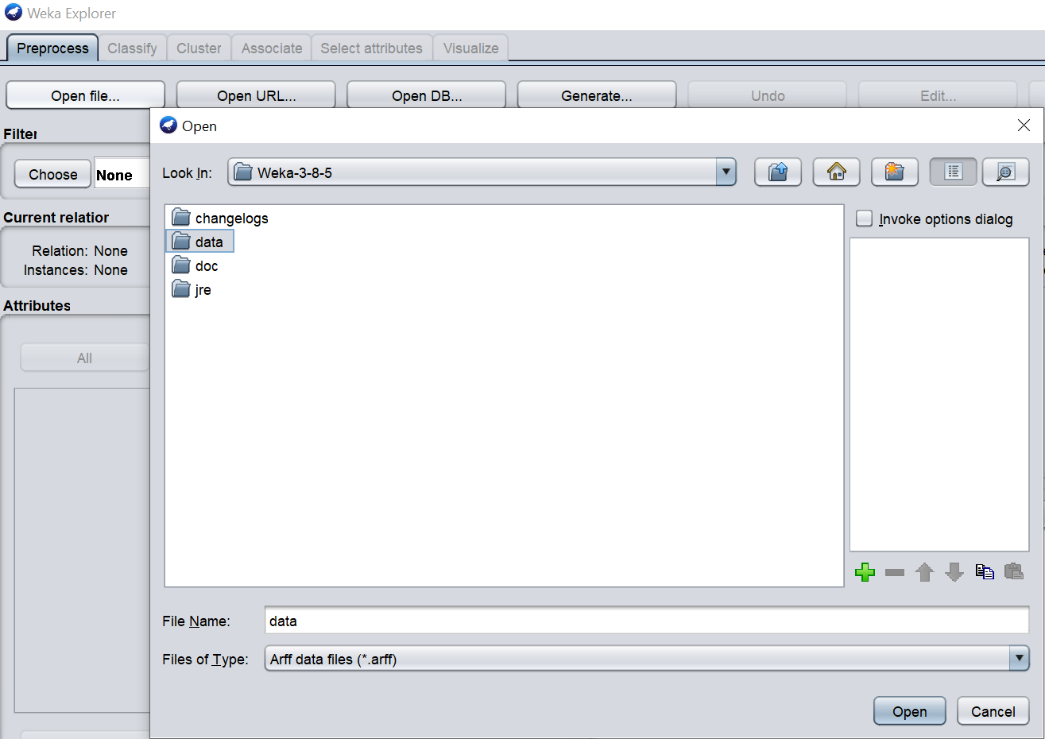

1. Select diabetes.arff file. The following window will be seen :

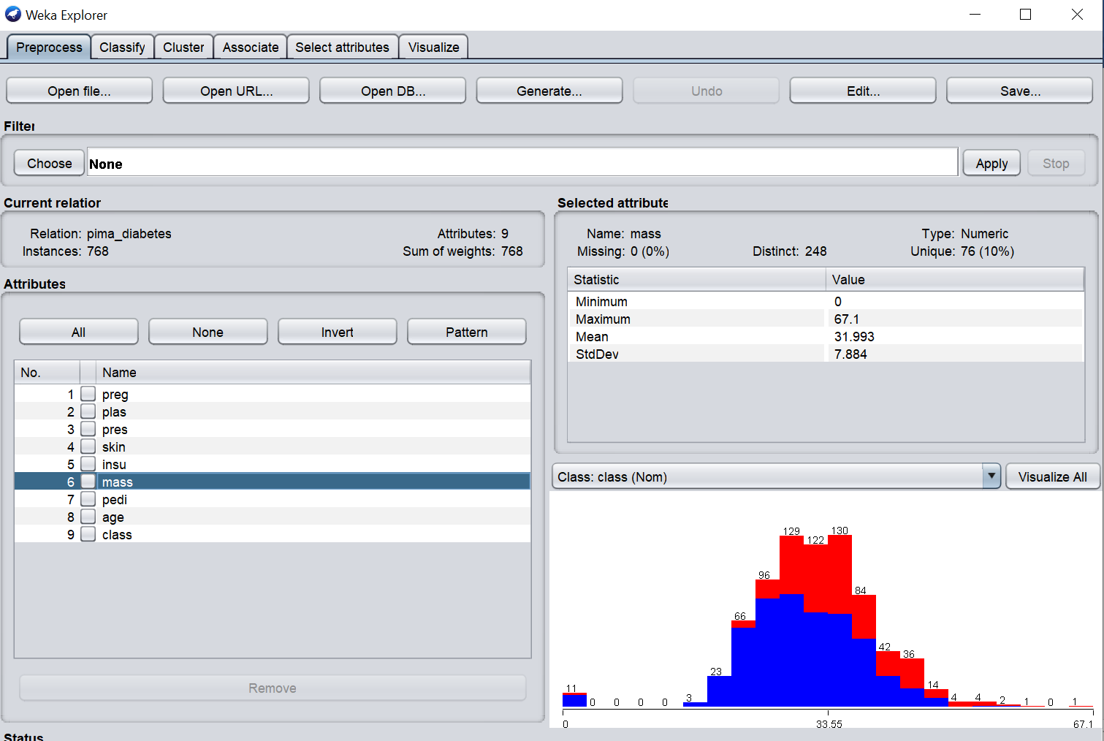

The relation or table name is pima_diabetes. It has 9 attributes or columns and 768 instances or rows. Every selected attribute has a statistic which is shown in the right part. Here, the selected attribute is mass --- which has values: Minimum – 0, Maximum 67.1 , Mean 31.993 ,Std. Deviation 7.884. All other attributes have their own statistics.

1. Choose Classify tab and then select Lazy option, then select IBk (Instance Based Learner).The IBk generates a prediction for all the rows in test dataset. Here it uses Euclidean Distance as a measure.

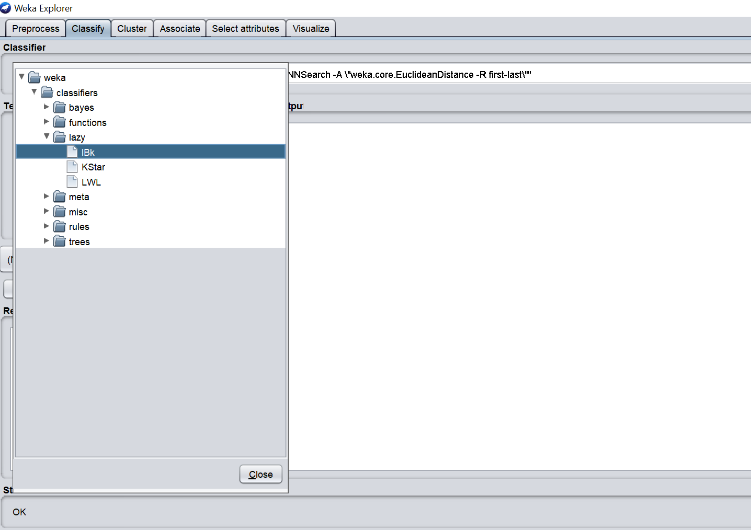

7)Click on Start . The following screen can be seen :

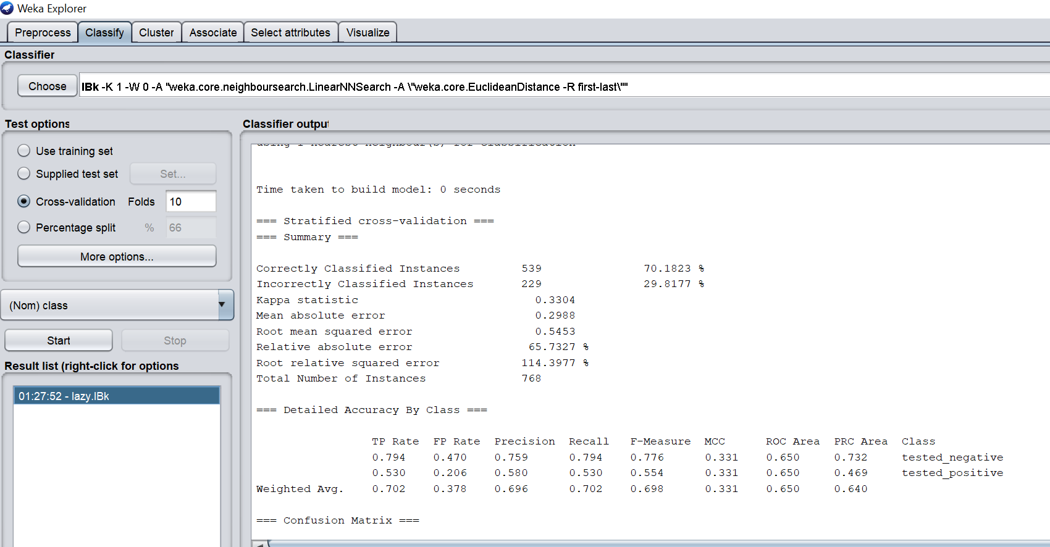

Cross-validation is a technique in which we train our model using the subset of the data-set and then evaluate using the complementary subset of the data-set.  Folds are the number of subsets that can be made. Here the number of folds is 10.

8)The following is the full output screen :

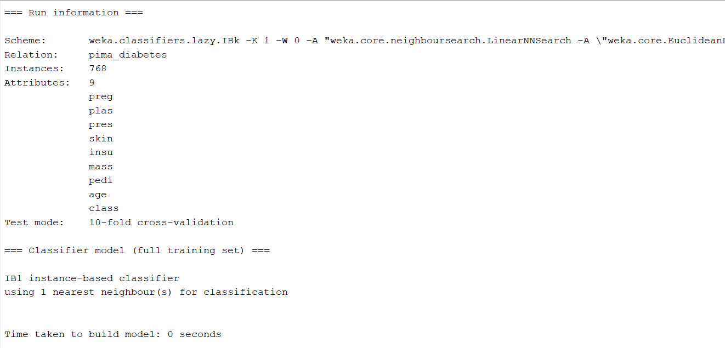

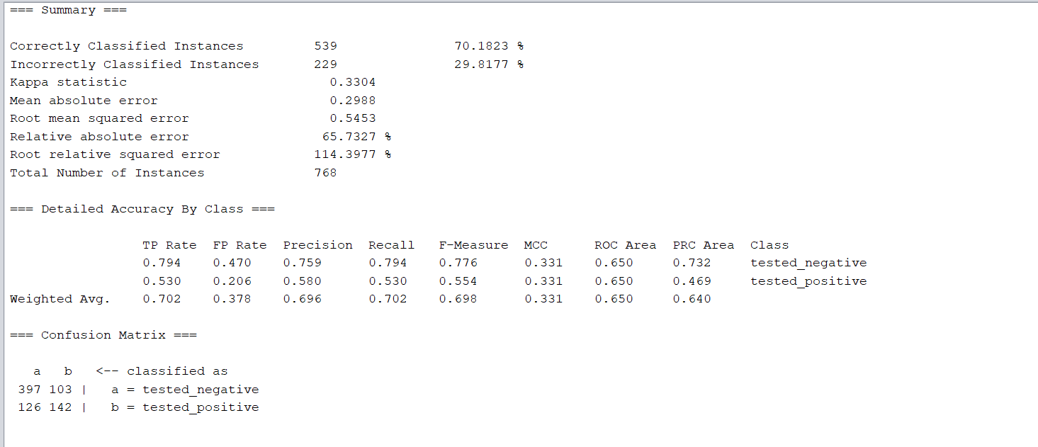

The correctly classified instances are 539 i.e. around 70% and the incorrectly classified instances are 229 i.e. 29.8177%.

Confusion matrix :

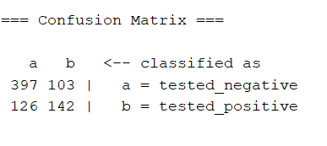

The values 103 and 126 are False Negative and False Positive respectively.

9) By left clicking on IBk option near Choose tab, we get the following window:

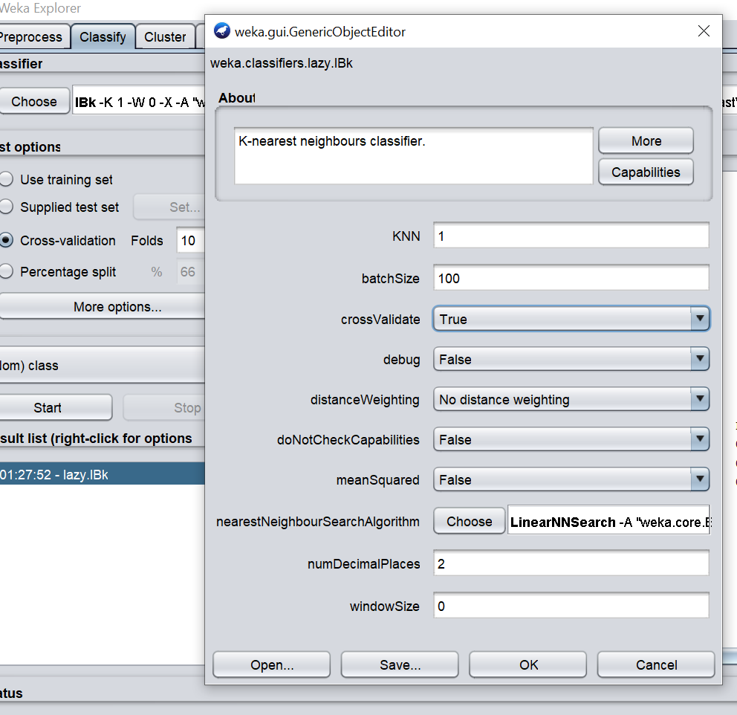

Here the values for different options can be set like eg: KNN i.e. the number of neighbours can be set.

**Questionnaire**

1. In KNN algorithm K stands for number of _____

a) neighbours b) errors c)Both d)None

2. Euclidean distance is the only measure of distance in KNN algorithm.

a) True b) False

b) c) cannot say d) both

3. WEKA stands for Waikato Environment for ______ Analysis

a) Knowledge b) Kappa c) Cannot Say d) All of the above

4. KNN is _____ algorithm.

a) lazy b) active c) both d)None

5. _____________ can have many number of folds.

a)Cross validation b)Standard deviation c)Absolute Error d) None

6. KNN is _________ machine learning algorithm

a) Supervised b) Unsupervised c) Cannot Say d) Both

**Module No 08**

**Experiment No. 05**

**Aim**: Implementation of market basket analysis.

**Objective**:- To implement market basket analysis in R

**Theory:**

Market Basket Analysis is a form of frequent itemset mining that examines consumer purchasing patterns by identifying relationships between the many goods in their "shopping baskets." By getting insight into which goods are commonly purchased together by customers, businesses may build marketing strategies based on the finding of these relationships.

Market Basket Analysis is a method of determining the value of a market basket.

MBA is most often used to help in cross-selling and up-selling. If you know that customers who buy trousers also buy belts, for example, you may advertise the belts on the same page or offer them as part of a bundle to try to boost sales. You may also advertise one product while seeing an increase in the other.

Customers' purchase patterns are depicted using "Association Rules" in Market Basket Analysis. A rule's interestingness is determined by two metrics: support and confidence.

Example:

Tea_powder => sugar [support = 4%, confidence = 70%]

1. A support of 2% for the above rule states that 2% of all the transaction under analysis show that tea powder and sugar are purchased together.

support(B => C) = P(B U C)

1. A confidence of 70% means that 70% of the customers who purchased tea powder also bought the sugar.
2. Lift is a metric that helps us figure out if combining two products increases our chances of making a sale.

Packages/functions used:

1)arules

It is used for displaying, manipulating, and analysing transaction data and patterns (frequent item sets and association rules)

2)arulesViz

Extends package 'arules' with various visualization techniques for association rules and item sets.

3)inspect()

 It summarizes all relevant options, plots and statistics that should be usually considered

4) is.redundant()

It finds redundant rules

5)apriori()

From a given collection of transaction data, apriori() creates the most relevant set of rules. It also demonstrates the rules' support, confidence, and lifting. The relative strength of the rules may be determined using these three criteria.

6)plot()

It is used to visualize association rules and item sets. It has in it implemented several popular visualization methods like scatter plots.

**Algorithm:**

The Apriori algorithm seeks out "often recurring item sets." An itemset is a collection of related items (such as products in a basket) whose frequency of co-occurrence is determined by a user-defined "support" level.

1)Read through the entire transaction.

2)Calculate the value of support for each item.

3) If the item's support is less than the minimum, it should be discarded. Otherwise, add it to the frequently used itemset.

4)Determine the level of confidence for each non-empty subset.

If the confidence is less than the minimum, the subgroup should be discarded.

**Program:**

1)library(arules)

2)library(arulesViz)

3)inspect(Groceries)

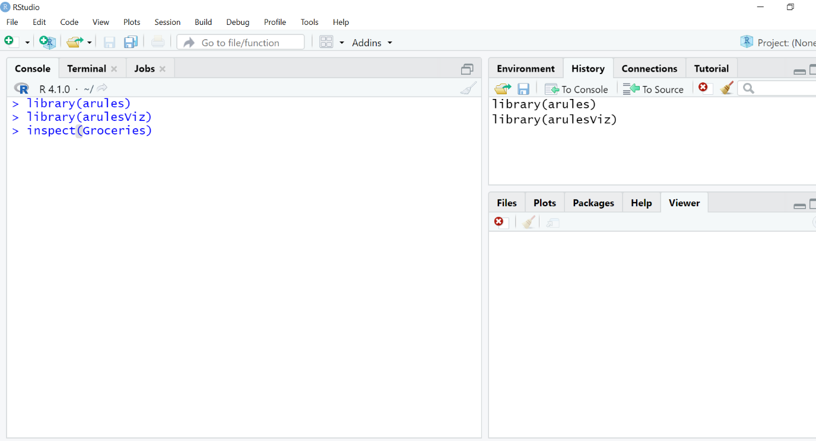

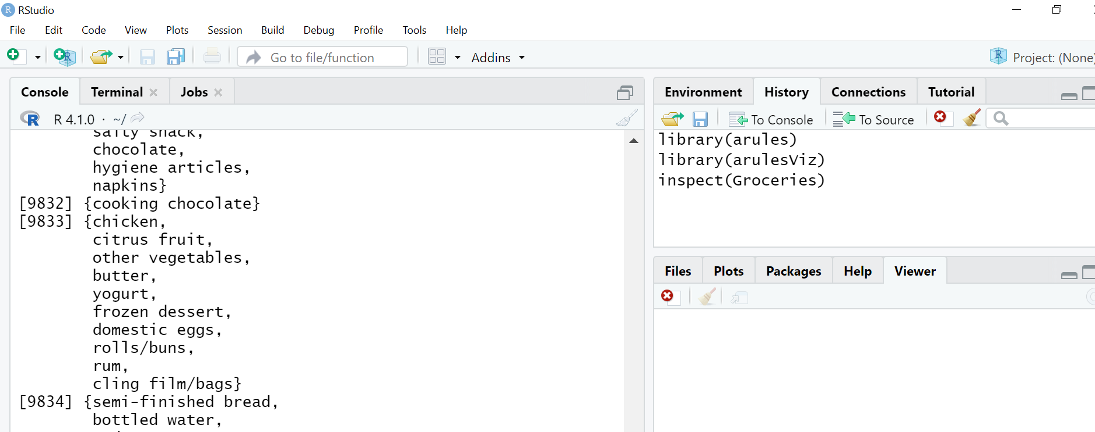

4)grules<-apriori(Groceries)

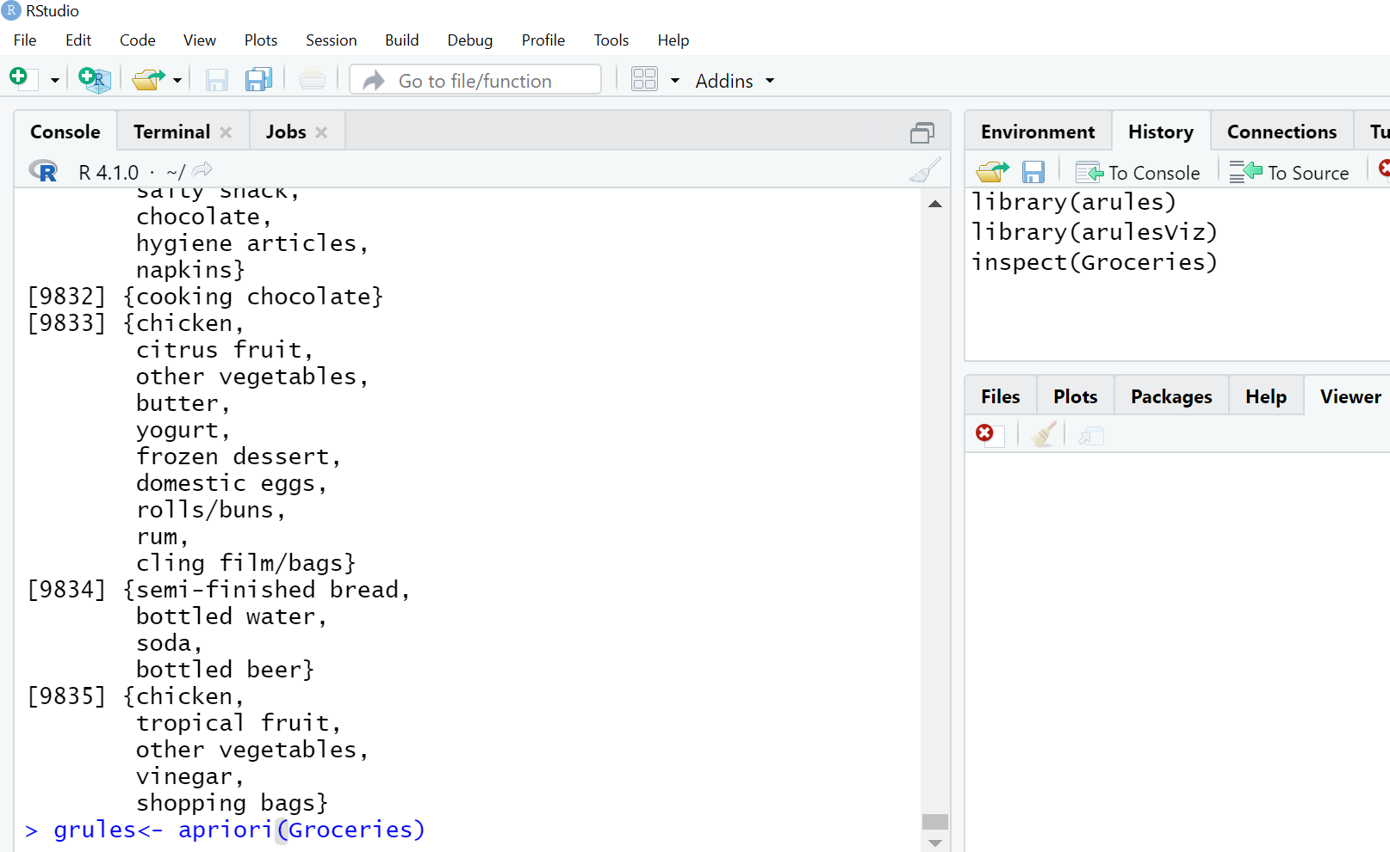

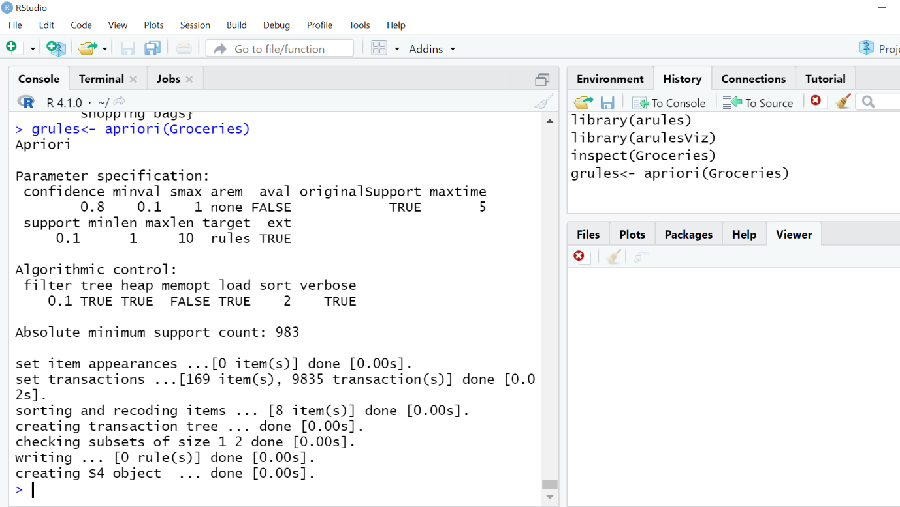

5) grules <-apriori(Groceries, parameter=list( supp = 0.001 , conf = 0.8 ))

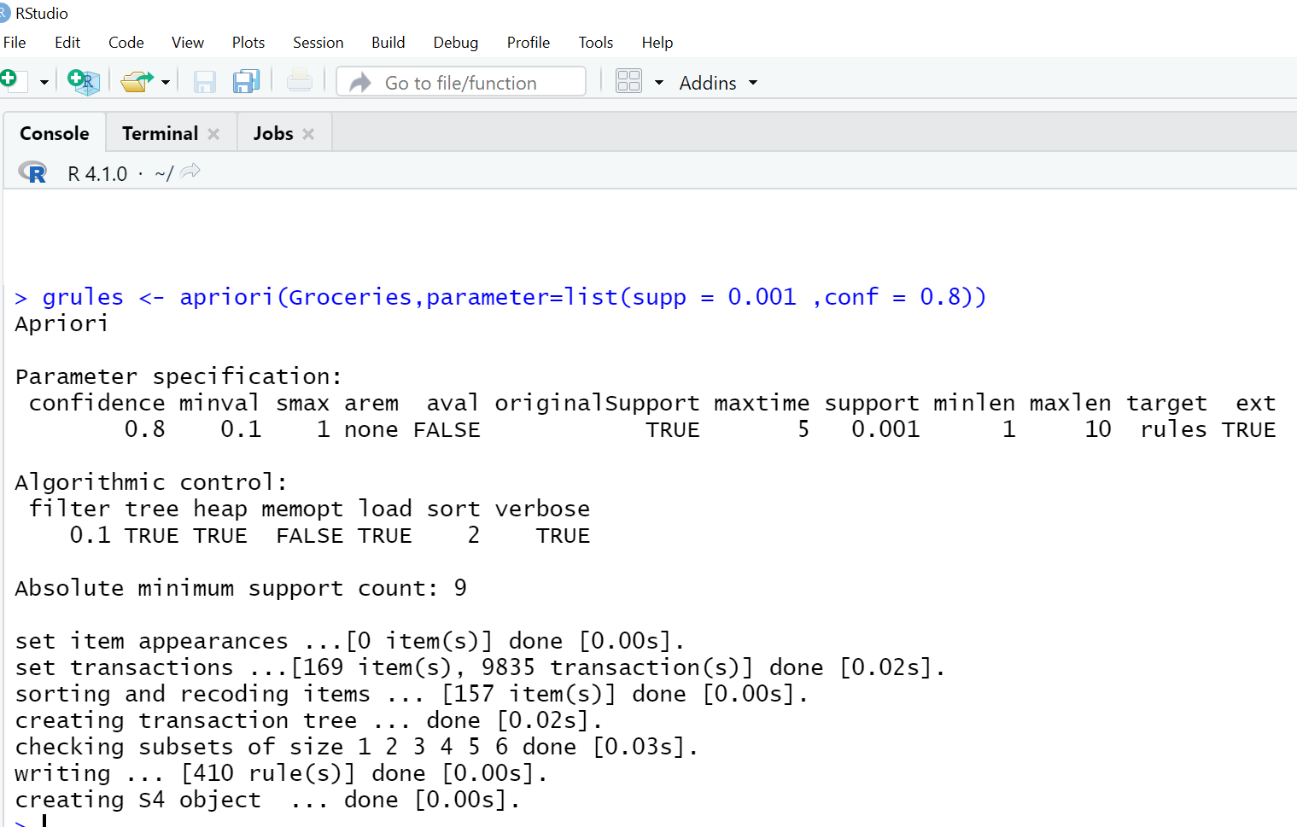

6)inspect(grules[1:5])

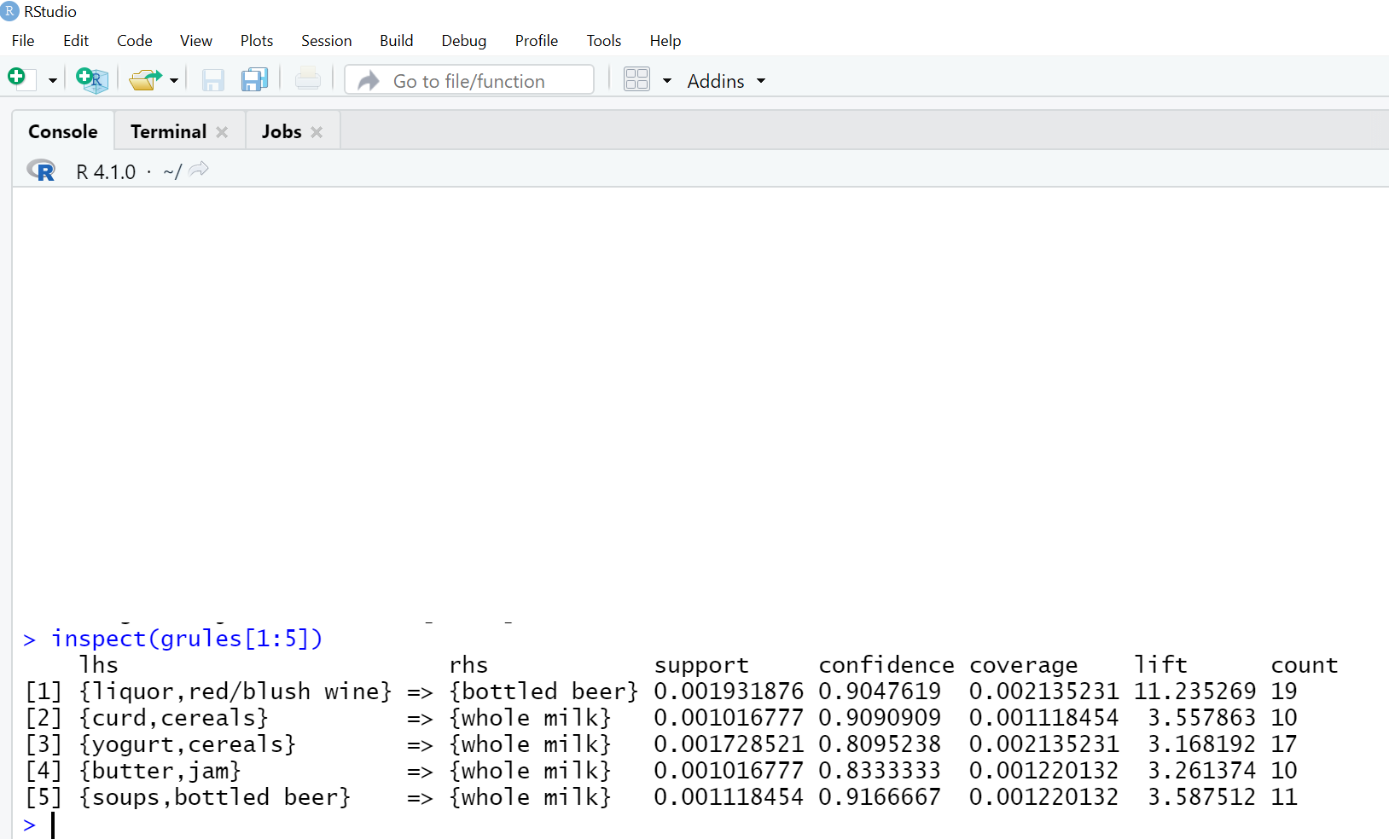

7)grules <- sort (grules, by = ” support ”,decreasing = T)

inspect(grules[1:10])

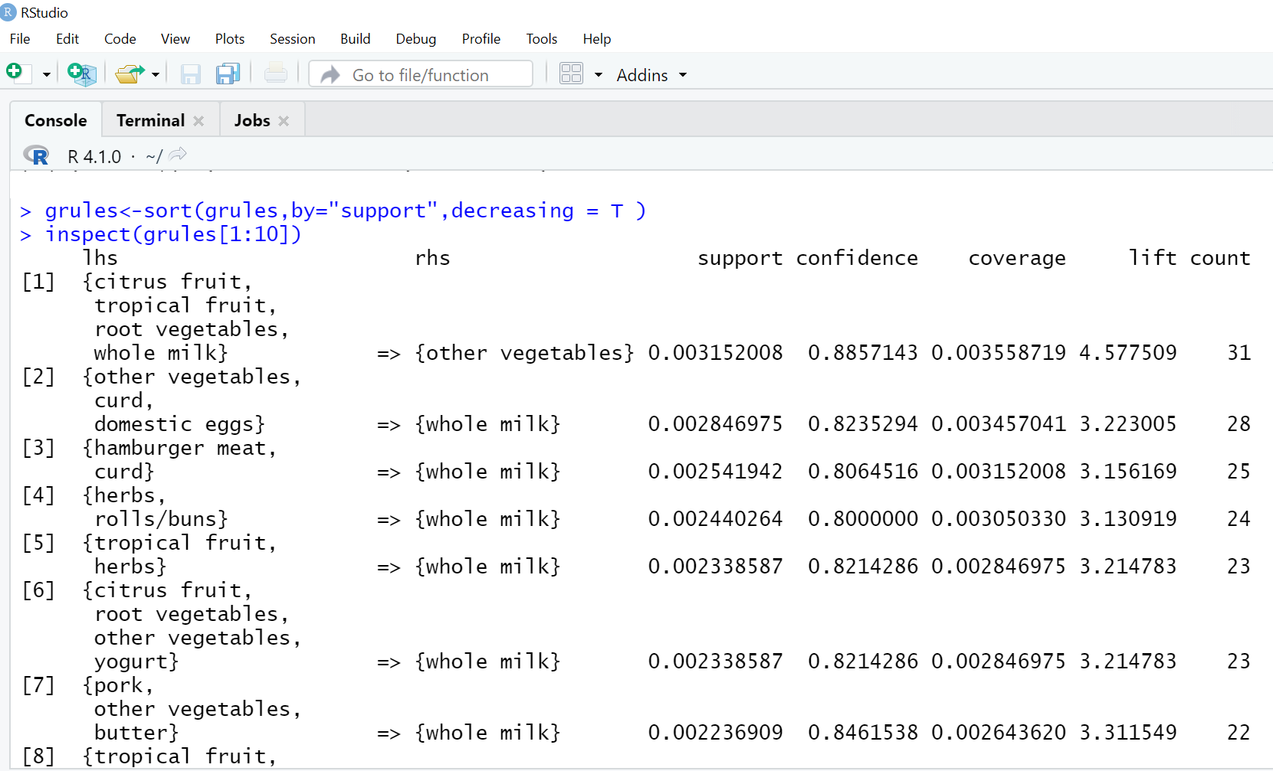

8)redundant_grules <- is.redundant(grules)

9)summary(redundant_grules)

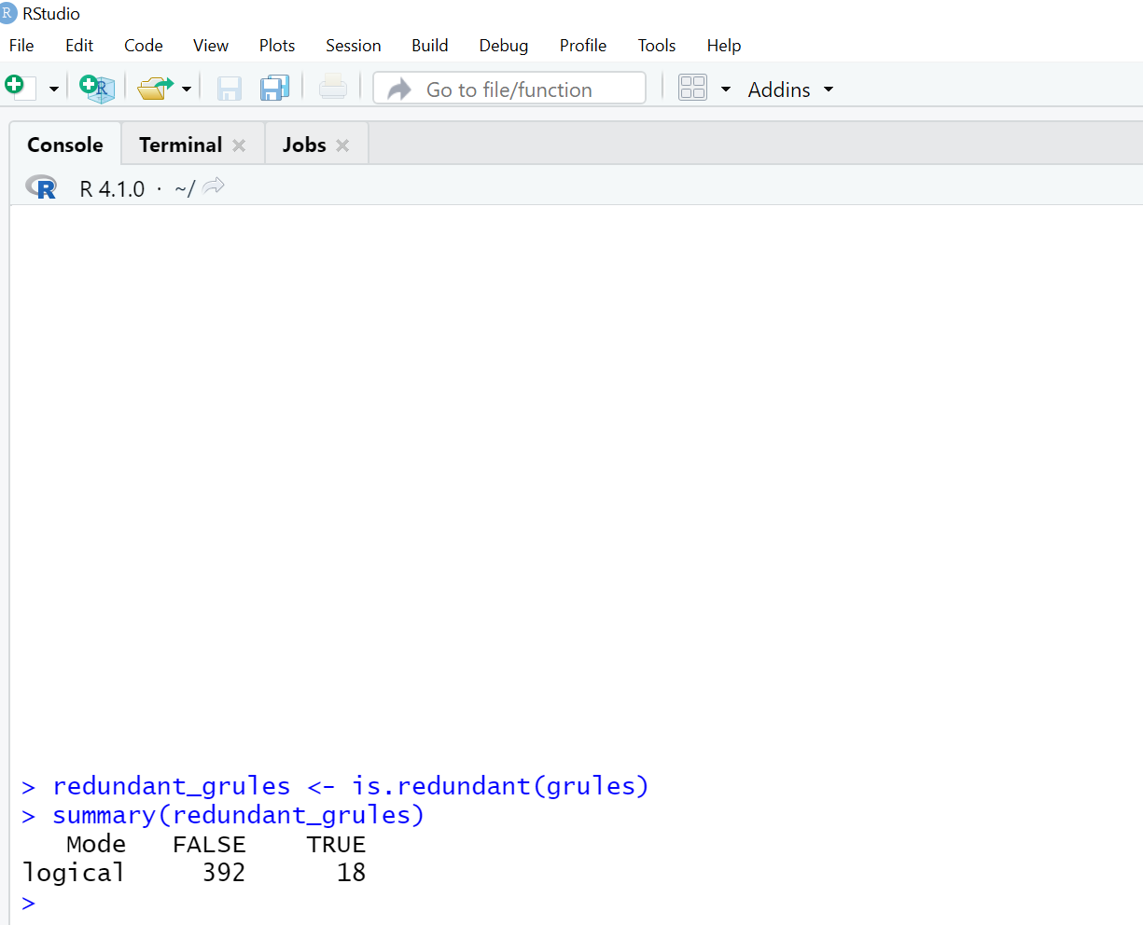

10) grules<-grules[!redundant_grules]

11) inspect(grules)

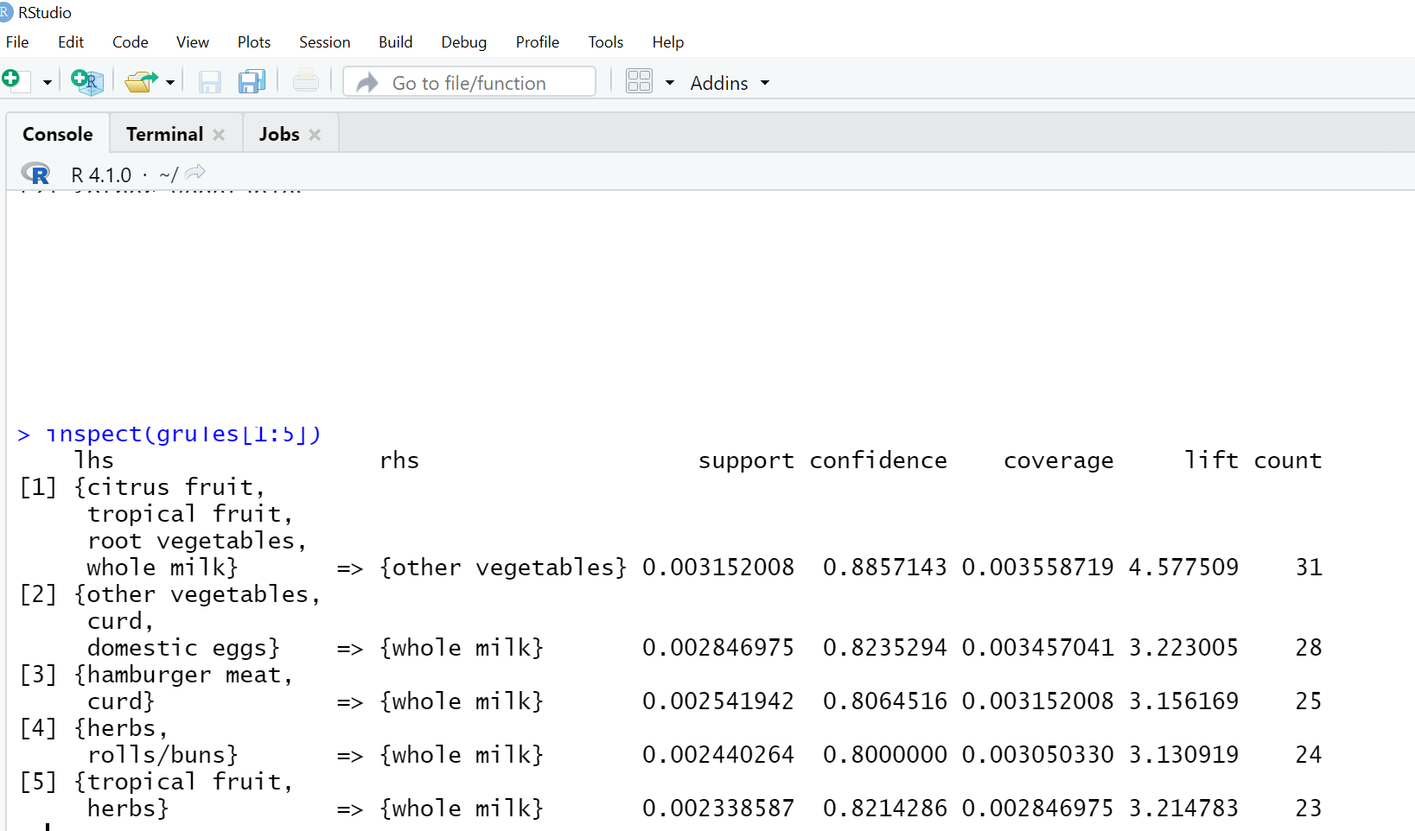

12) grules_whole_milk <- apriori(Groceries, parameter=list(supp = 0.0001,conf = 0.08), appearance=list(default="rhs”, lhs = "whole milk"))

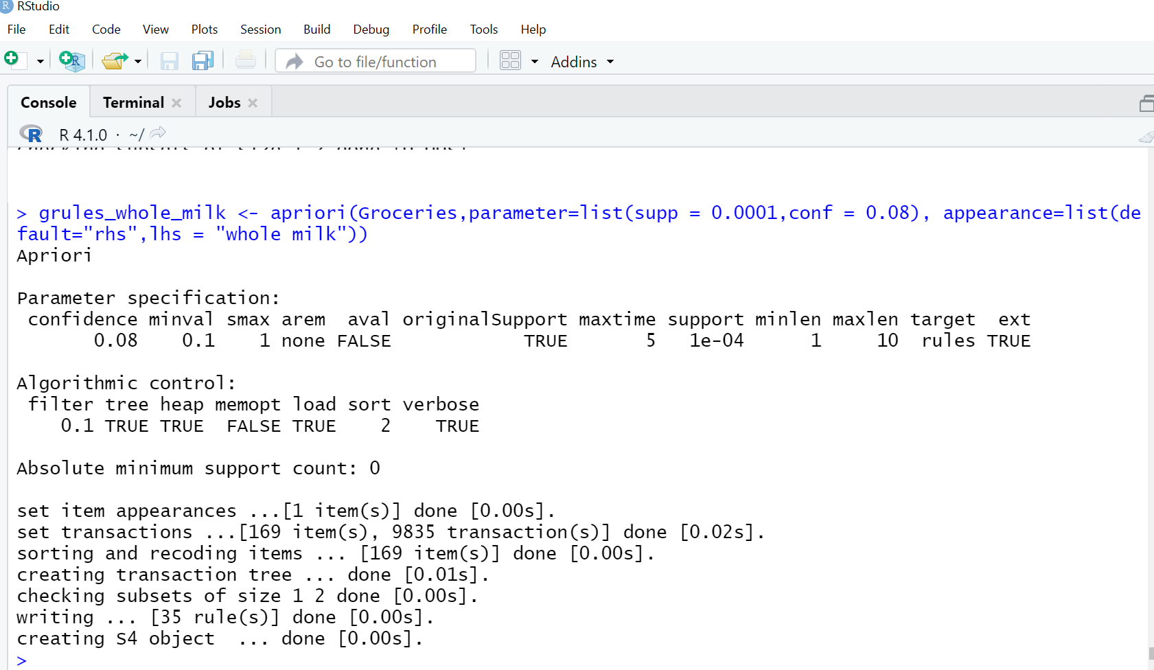

13) inspect(grules_whole_milk[1:7])

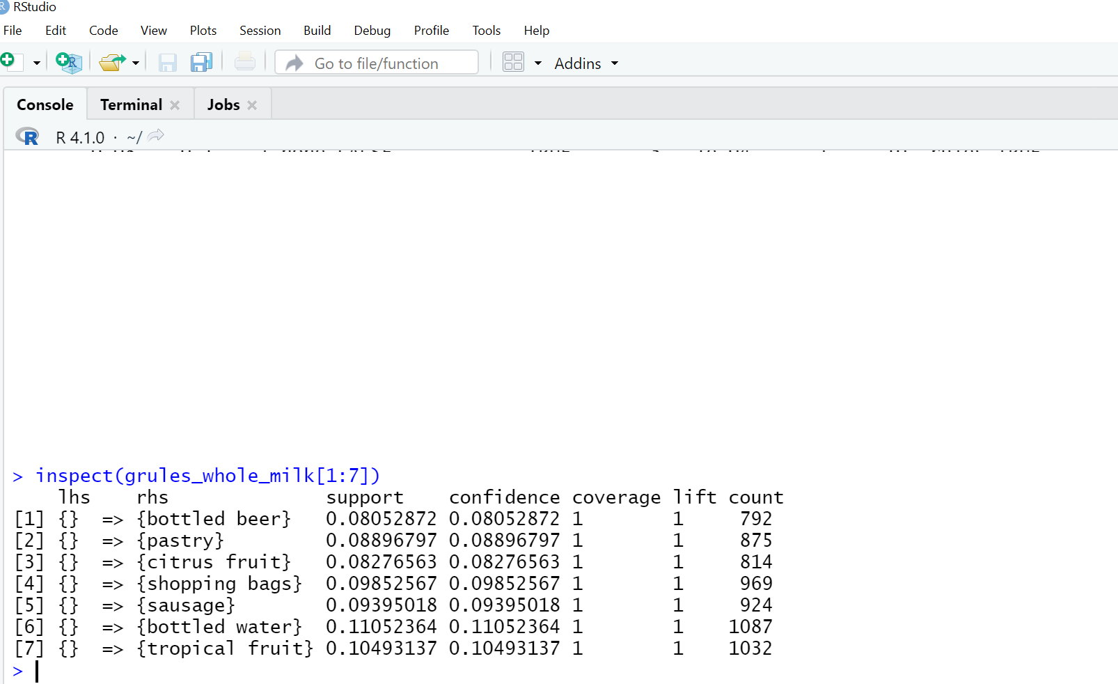

14) plot(grules_whole_milk, method = "graph" ,engine ="interactive")

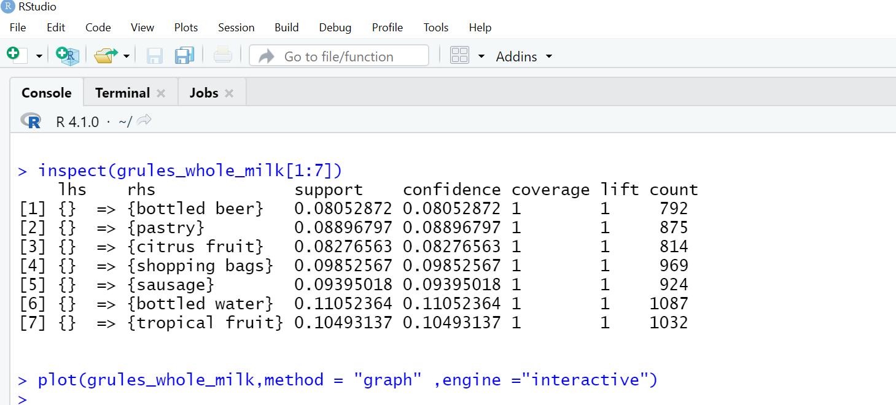

Graph:

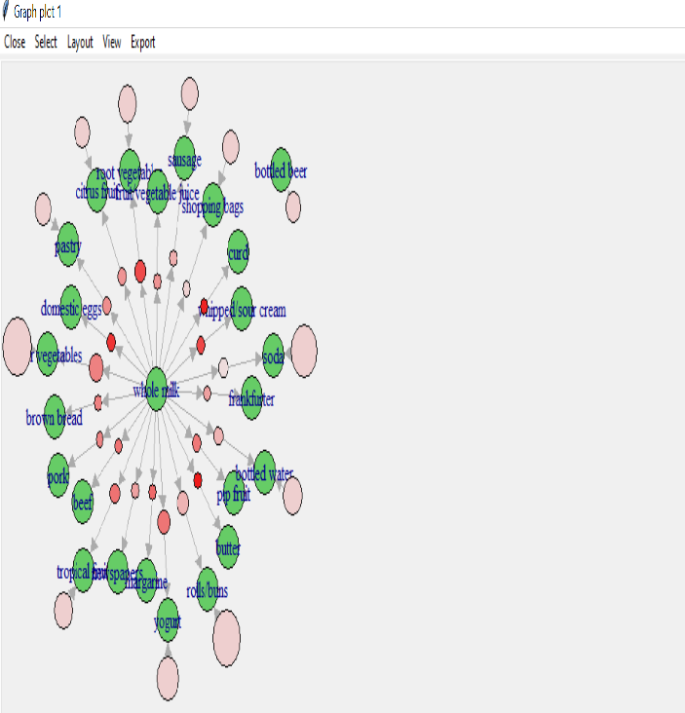

**Questionnaire**

1. Lift value _____ than 1 is desirable

a)greater b) lesser c)Both d)None

2. Support means number of occurrences of a transaction.

a) True b) False

b) c) cannot say d) both

3. arulesViz package is used for _____ of association rules.

a) visualization b) addition c) summarization d) All of the above

4. Apriori uses _____ knowledge of frequent itemset properties.

a) prior b) output c) transaction d)None

5. Support and confidence measure interestingness of a rule.

a)True b)False c)Both d) None

6. ______ is used when you want to find an association between different objects in a set.

a) Association Rule Mining b) Clustering c) Classification d) None

**Experiment No. 06**

**Aim**: To implement K means Clustering in R.

**Objective**:- To understand how Kmeans clustering is performed in R

**Theory:**

K means for Clustering is an unsupervised learning method that attempts to group data by similarity. There is no outcome to anticipate with unsupervised learning, thus the algorithm just tries to discover patterns in the data. We must indicate the number of clusters we want the data to be classified into in k, which stands for clustering.

The algorithm allocates each observation to a cluster at random and finds the cluster centroid. After that, the algorithm repeats two steps:

Reassign data points to the cluster with the closest centroid.

Calculate each cluster's new centroid.

Packages/functions used:

1. cluster

It is used in finding groups in data

1. set. seed()

sets the starting number used to generate random numbers

1. kmeans()

Perform k-means clustering on a data matrix.

1. plot()

It is used  for grouping items in terms of a smaller number of observed clusters.

1. table()

Carries out categorical data tabulation with the variable and its frequency.

**Algorithm:**

1. Select the number of clusters K.
2. The centroids are chosen at random from a set of K locations (Not necessarily from the given data).
3. Assign each data point to the centroid that is closest to it, resulting in K clusters.
4. Calculate and position each centroid's new centroid.
5. Each data point should be assigned to a new cluster.

**Program:**

library(ClusterR)

library(cluster)

# Removing previous label of Species from the original Iris dataset

iris_new <- iris[, -5]

# Initializing seed value

set.seed(200)

kmeans.re <- kmeans(iris_new, centers = 3, nstart = 10)

kmeans.re

kmeans.re$cluster

# Building confusion matrix table

confusion_matrix <- table(iris$Species, kmeans.re$cluster)

confusion_matrix

#Plotting the clusters

plot(iris_new[c("Sepal.Length", "Sepal.Width")],col = kmeans.re$cluster,main = "Showing 3 different Clusters")

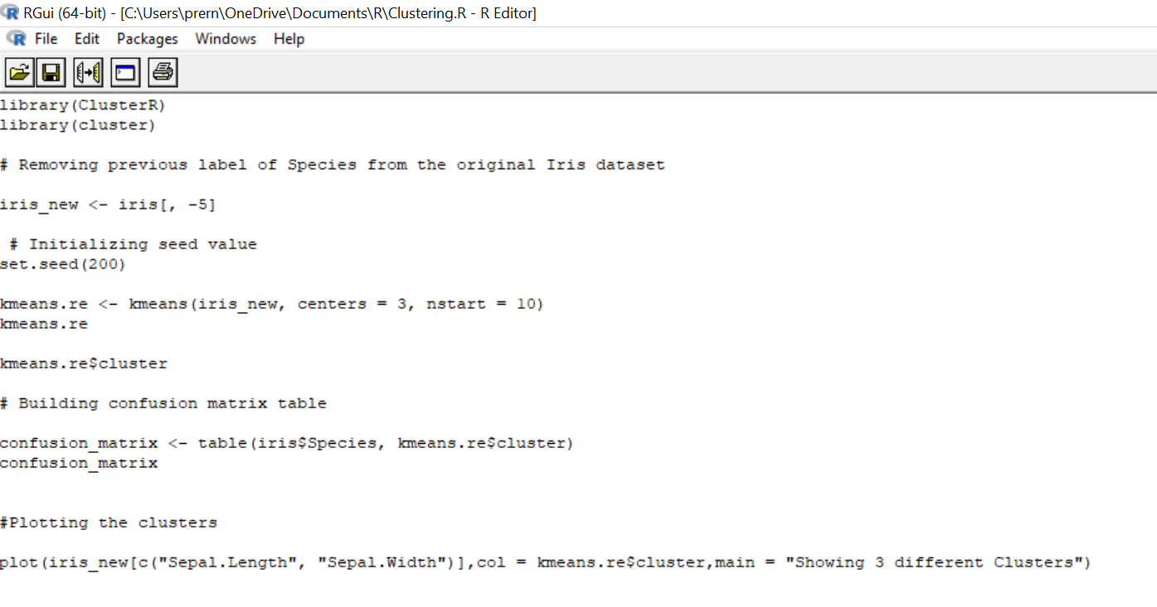

Output :

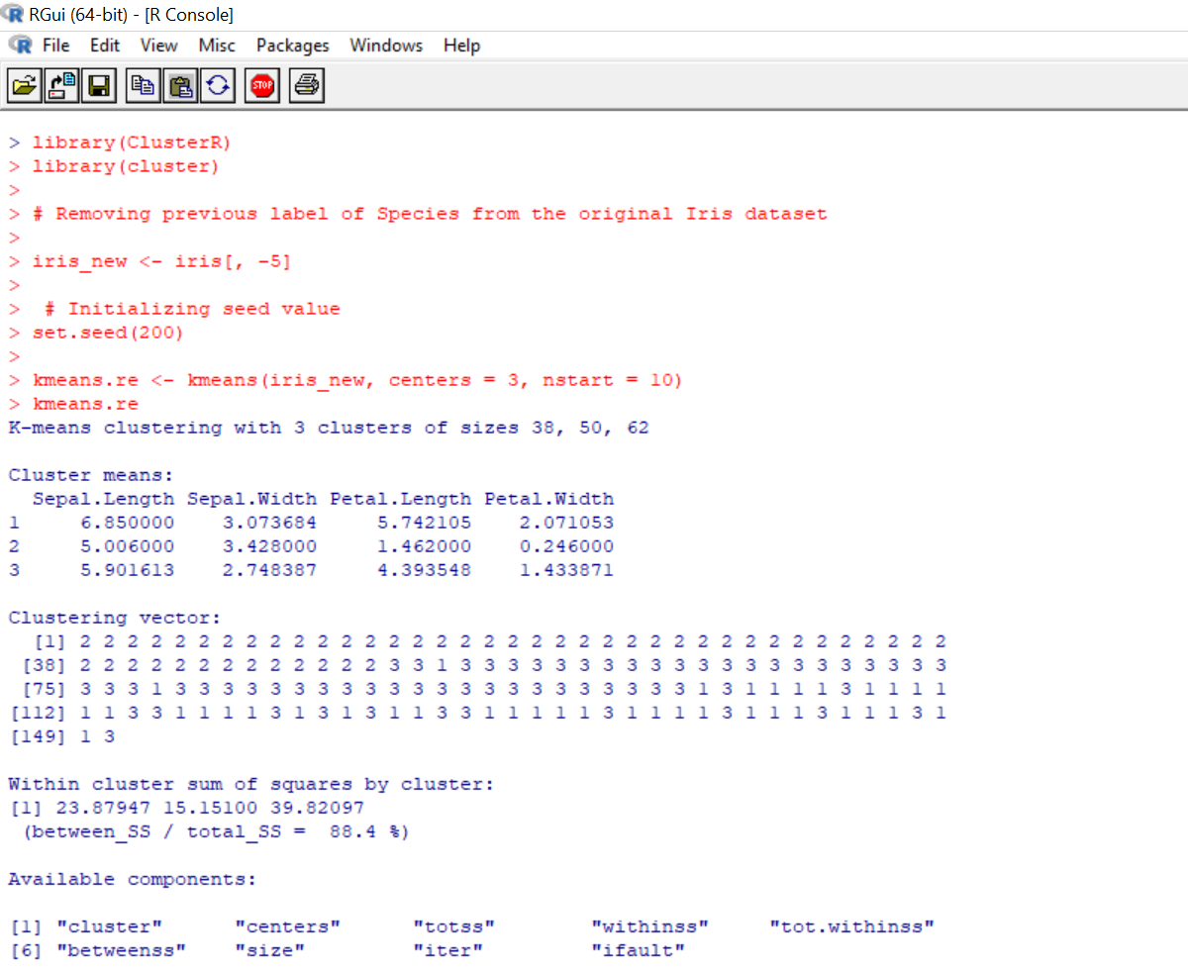

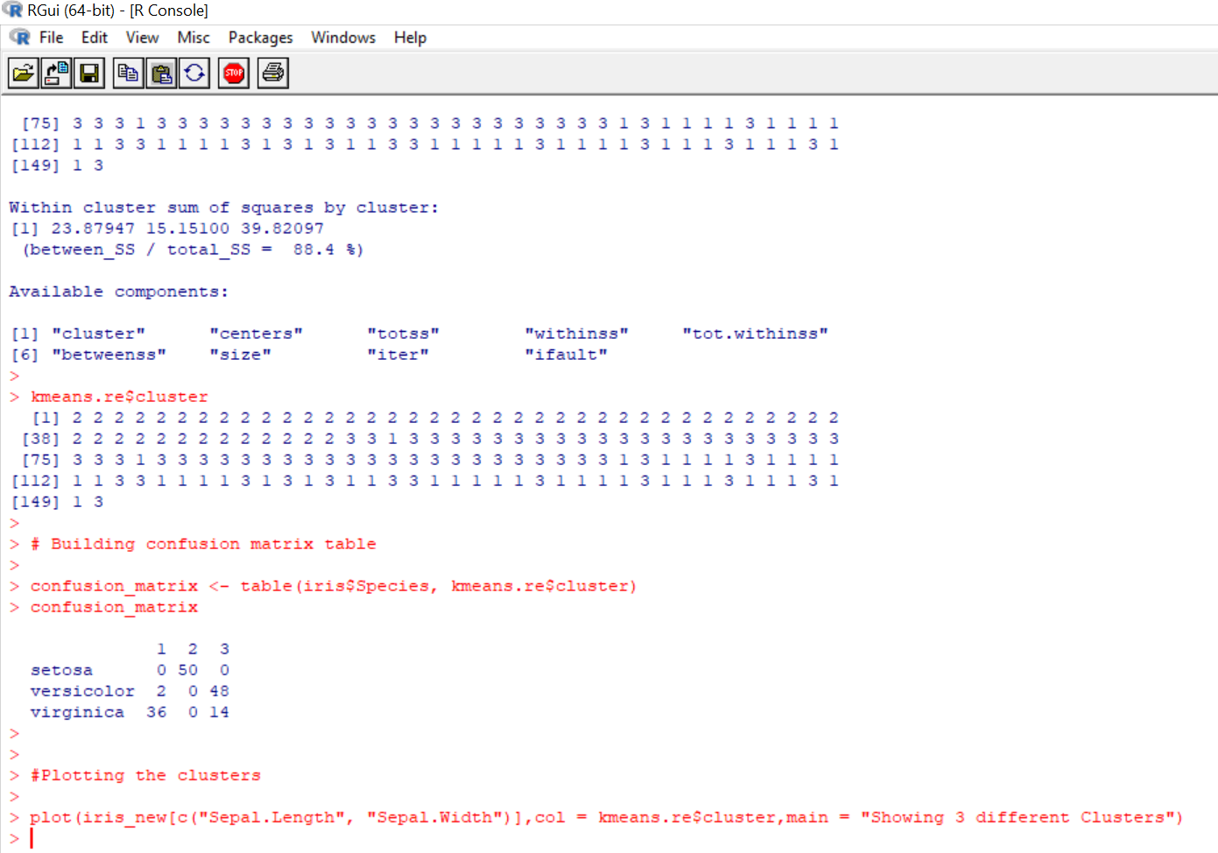

**Output:**

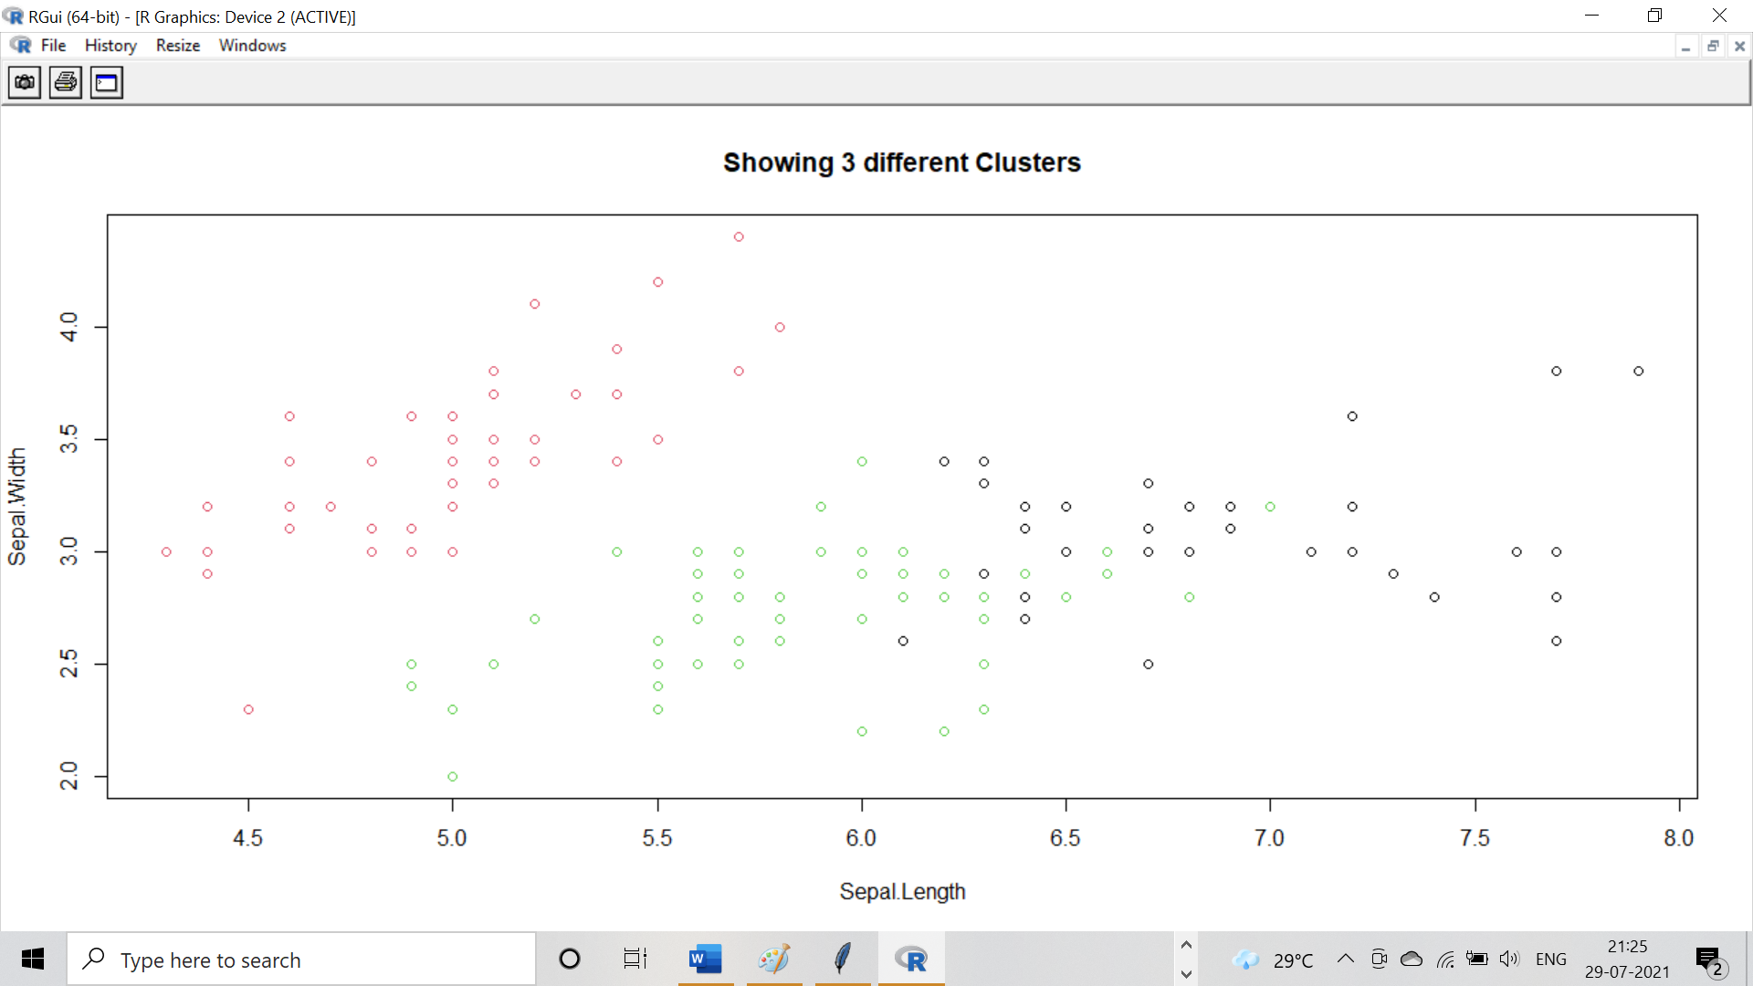

**Questionnaire**

1. K Means Clustering is an ___________ learning algorithm

a)unsupervised b) supervised c)Both d)None

2. K is the number of clusters in a dataset.

a) True b) False

b) c) cannot say d) both

3. ________ learning means no outcome can be predicted, and the algorithm just tries to find patterns in the data.

a)unsupervised b) supervised c)Both d)None

4. Iris dataset is inbuilt dataset.

a) True b) False

b) c) cannot say d) both

5. The more variation we have within clusters, the more similar the data points are within the same cluster.

a)True b)False c)Both d) None

6. The groups of customers can be formed based on their behaviour ---- we can use k-means clustering for this task.

a)True b)False c)Both d) None